Assessment Report – Low Complexity DA

Assessment Team
DA – Planner | Nicole Tobias | DA – Manager | Jennifer Sneesby
DA – Engineer | Matt Sturley
Decision Delegate | Stephen Glowacz, Director EDQ Development Assessment

m

Recommendation
It is recommended;

- That the Delegate, under delegated authority and in accordance with the Economic Development Act 2012 (ED Act), approve the development application for a PDA Development Permit for Material Change of Use for a Shed Associated with existing Transport Depot and dwelling house at 672-676 Mount Cotton Road, Sheldon, subject to the Approved Plans and Documents and the PDA Development Conditions (refer Decision Notice at D26/36043).

- That the PDA Decision Notice be provided to the applicant and the relevant local government, in accordance with section 89 of the ED Act.

Application Details

DA Reference No: | DEV-2026-STL-4364
Type of Approval: | PDA Development Permit
Proposal Description: | Material change of use for a shed ancillary to the existing transport depot and dwelling
Applicant: | Suzanne Hembrow, Site Town Planning
Properly Made date: | 11 February 2026
Info Request date: | Nil.
Decision Due date: | 25 March 2026 (30b.d KPI)  10 April 2026 (40b.d KPI)

Property & Site Details

Priority Development Area: | Southern Thornlands PDA
Site Address: | 672-676 Mount Cotton Road, Sheldon
Real Property Description: | Lot 32 on SP244103
Area of Site: | 30,530m²
Property Owner(s): | Terri Sherwood & Paul Thompson
Locational context: | The site is located directly off Mount Cotton Road located to the west. The site is located adjacent to a Vehicle Depot in different ownership and operations, and further south is a landscape supply depot. The area is an operational Vehicle Depot which was approved by Council in 2016.
Site attributes: | The property is sparsely vegetated, with some scattered trees around the dwelling house and shed, noting that no vegetation is required to be removed to facilitate the proposed shed. The topography falls from the centre of the site to the front and rear, with a dam to the rear, and existing transport depot located centrally on the property.

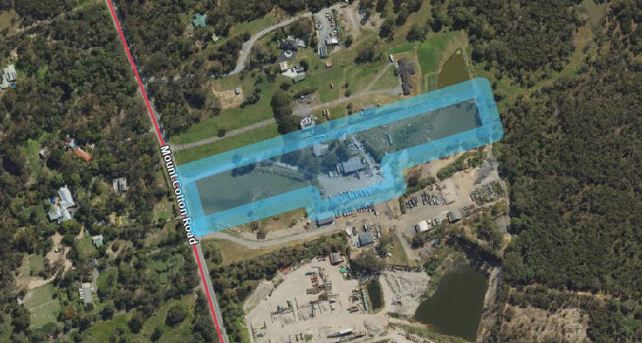

State Interests

The following state interests and assessment criteria are relevant to this application. A full list of identified state interests are listed on the State Interest Checklist (Source Ref: D26/36472).

State Interest | Assessment and action/resolution
Bushfire – Medium potential bushfire intensity & Potential impact buffer | The proposed development for a shed will have a condition on the permit to ensure the development complies with Australian Standards for constructing within a Bushfire Prone area. As the shed is proposed in a cleared location, with minimal vegetation in the surrounding area, the risk is minimal.
State Controlled Road | The application was referred to TMR to notify them of the active application off Mount Cotton Road. The proposal is not intending to intensify the existing operation, with no increase to vehicle ingress/egress onto the state controlled road.  TMR’s concerns and conditions are discussed further in section 7 of the report.

Relevant Site History & Preliminary Approval

While EDQ has not issued any development approvals for the subject site, there are some approvals of note that relate to the subject site.

Application Type | Date | Description
Material Change of Use for Vehicle Depot | Approval date 20 January 2016 (Council Ref:  MCU013519) | The existing depot is still operational on the subject site. It is noted that upon referral to TMR and Redlands City Council, the use has been identified with concerns, these will be addressed below.
Other Change to Development Approval MCU013519 Material Change of Use for Vehicle Depot | Withdrawn (Council Ref: MCU23/0066) | The applicant was requested to withdraw the application in order to allow for changes to ShapingSEQ come into play. The applicant lodged a subsequent application the following year.
Other Change to Development Approval MCU013519 Material Change of Use for Vehicle Depot | Prohibited Development 11 December 2024 (Council Ref: MCU24/0195) | The applicant was notified that the site was located within Category 1 SEQ development area, which is a land designation under the South East Queensland Regional Plan (Shaping SEQ 2023).  “Council reviewed the lodged application and advise that under the Planning Regulation 2017 Schedule 10, Part 15, Division 1, Section 22A the proposed development constitutes prohibited development.”  The subject application was prepared as a scaled down version of this application, and clearly articulated to be storage only, with no increase to Depot Operations.

Assessment & Key Issues

The applicant has provided the following statement with the lodgement material for this application:

The proposed Shed will be utilised for the storage of domestic items associated with the maintenance of the property (mower, trailer, household storage) and storage associated with the Vehicle Depot use. The proportion of the shed delineated to each ‘use’ is not known however, the use of the Shed will not alter the existing Vehicle Depot approval. Meaning, the shed will not increase the number of parking bays or increase the intensity of the use of the Depot. The shed is an ancillary structure that will improve the amenity of the existing dwelling and allow additional storage for the existing Depot patronage. The shed is not proposed to be an intensification of either the Dwelling House use or the Vehicle Depot use.

The plans provided to Council for the Other Change applications (referenced above) have not been amended wholistically and still reflect an increase in vehicle parking spaces which is not intended to take place, as clearly articulated by the applicant. Further discussion with the applicant has confirmed that the proposed shed will not result in increased operations on site and plans amended in red with conditions to this effect were agreeable.

These conditions will include maintaining vehicle movements and onsite number of trucks to 10 trucks in a 24 hour period as per the existing approval. Furthermore, TMR provided EDQ with conditions to include on the development permit as it has been identified that the operation commenced prior to receiving approval and construction of a Basic Left Turn and Right Turn Treatment to the property (original condition below).

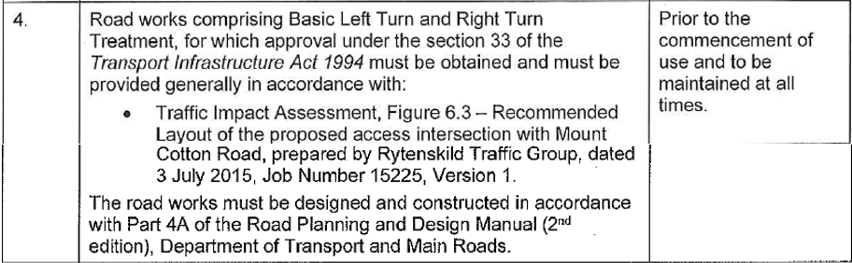

However, the proposed updated condition recommended by TMR (below) increases the turning treatment requirements, based on their higher estimated vehicle movements extrapolated from the approval rates identified in the Traffic Impact Assessment (TIA) provided to Council and TMR (i.e. there are 3 times the number of truck car parks proposed on site).

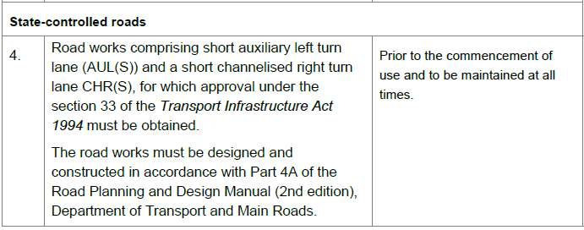

In order to maintain compliance with the existing approval and retain the existing operation on the site as per the applicant’s advice, EDQ proposes to include the same access requirements from Council’s 2016 approval over for the subject application and impose conditions to ensure consistency with the existing approval and the described intent.

Internal Referrals

6.1 Engineering
Comments and conditions regarding the proposal were received from engineering on 16 March 2026 (Source Ref: D26/38122)

6.2 Infrastructure Charges
Model conditions regarding infrastructure charges for the proposed development are recommended to be included in the approval.

External Referrals

The application was referred to the following external parties for comment and advice. A summary of the comments received is provided below;

Redland City Council
Summary of comments/issues | Discussion and action/resolution
Scale and Intensity – the proposal increasing from 10 trucks on site to 30 has not been addressed | As stated above in section 5 of this report, the applicant has clearly articulated in the application documentation that the proposed shed will not increase the vehicle movements on site.  The applicant has agreed to conditions and plans with amendments in red to provide certainty that the operations do not increase from the existing approval from Council. This includes the reiteration of conditions from the initial approval to limit operations onsite.
Traffic Impact – the site being off Mount Cotton Road has a significant traffic impact | As stated above, the applicant has clearly articulated in the application documentation that the proposed shed will not increase the vehicle movements on site. To ensure no confusion with regards to an increase to vehicle movements/parking, a plan amendment (in red) has been prepared for approval.  However, I note that the application was referred to TMR, with further discussion below.
Environmental impacts – the intensification of the transport depot would result in stormwater issues. | As stated above, the applicant has clearly articulated in the application documentation that the proposed shed will not increase the operation of the existing transport depot and is primarily intended to be used for storage on site associated primarily with the dwelling. Therefore, the increased environmental impacts are negligible.  A condition for non-worsening stormwater has been conditioned by EDQ’s engineer in addition to the conditions requiring no increase in operations on site.
Emissions – Noise, Lighting, Dust and Contaminant impacts | Council’s concern regarding the intensification of the use having increased emissions is noted and can be addressed through conditions. However as stated above, the proposal will not intensify the vehicle movements, storage or hours of the transport depot as the shed is for storage of equipment only, otherwise associated with the dwelling house.
Bushfire impacts | The proposed shed is located adjoining the potential bushfire impact overlay; however a condition will be included in the development permit to ensure the structure is constructed in accordance with the Australian Standards for bushfire impacted buildings as requested by Council.
Flood/stormwater impacts on the surrounding area | The proposal will result in increased impervious area but is unlikely to result in significant impacts. A condition imposed by EDQ’s engineer includes non-worsening stormwater impacts which has been amended to include reference to non-worsening to State Controlled Roads as TMR have requested additional conditions to ensure the delivery of the shed will not impact the State Controlled Road (Mount Cotton Road).

Department of Transport and Main Roads (TMR)
Summary of comments/issues | Discussion and action/resolution
Existing access condition non-compliant | TMR have advised the existing conditions of approval for the transport depot on site included the provision of road works to construct a basic left turn and right turn treatment.  The response from TMR has included the request for road works for a short auxiliary left turn lane (AUL(S)) and a short channelised right turn lane CHR(S) on Mount Cotton Road. However, the proposed development does not include an increase to any traffic movements for the site and will remain limited to 10 vehicle movements per day and 10 parking bays.  The increase to turning lane treatments has been based on the forecast by TMR that the application would increase the vehicles from 10 to 30 per day, therefore movements would increase to align. However, this is not the intention of the proposal, therefore a basic left turn and right turn treatment can be carried across from the existing approval.
Stormwater impacts on State Controlled Road | TMR included a condition for non-worsening of stormwater impacting the state controlled road. Due to EDQ’s engineer providing a similar condition, TMRs specific condition was not included on the decision notice as the EDQ’s engineers recommended a condition to clearly state that no net worsening to state controlled roads and adjoining properties is permitted. Therefore, the concern from TMR has been addressed through the proposed condition.
Compliance condition | TMR also included a standard compliance with approved plan condition which is not required as EDQ includes a standard condition of maintaining compliance with condition.

PDA Development Conditions

Model conditions are recommended to be included in the approval for the proposed development. However non-standard conditions and/or amendments to plans (made in red) are also recommended to address site-specific and unique requirements of the proposal. Refer to section 5 (above) for further details.

Human Right Impact Assessment

In accordance with the Human Rights Act 2019 (HR Act), the human rights relevant to this decision are:
- Freedom of movement;
- Freedom of expression;
- Property rights (right to own property and not be arbitrarily deprived of property).

It is considered that a decision to approve the proposed development will not limit (or interfere with) the above listed human rights as;
- the development will not arbitrarily restrict the movement of people or limit the ability of people to move through open space;
- public notification of the application was not required;
- the development will not adversely affect how people may use their land.

Appendix 1 – Proposal plans

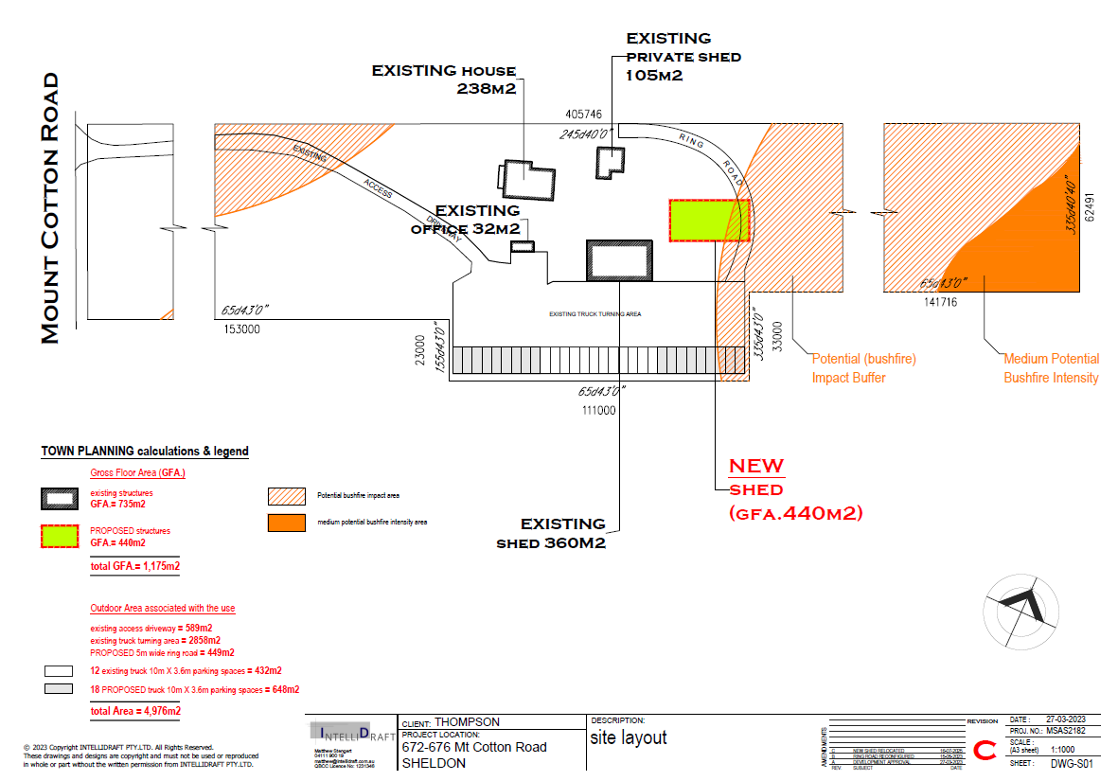

Amended in Red

