Assessment Report – Low Complexity DA

Assessment Team
DA – Planner | Nicole Tobias | DA – Manager | Jennifer Sneesby
DA – Engineer | Demi Ebrahimi
Decision Delegate | Carolyn Mellish, Director EDQ Development Assessment

Recommendation
It is recommended;

- That the Delegate, under delegated authority and in accordance with the Economic Development Act 2012 (ED Act), approve the development application for a PDA Development Permit for Reconfiguring a Lot – 1 into 8 lots and road reserve over 2 stages at 554-700 Yaamba Road, Norman Gardens, subject to the Approved Plans and Documents and the PDA Development Conditions (refer Decision Notice at D26/26853).

- That the PDA Decision Notice be provided to the applicant and the relevant local government, in accordance with section 89 of the ED Act.

Application Details

DA Reference No: | DEV-2026-CQU-4322
Type of Approval: | ROL
Proposal Description: | Development Permit for Reconfiguring a Lot – 1 into 8 lots and road over 2 Stages
Applicant: | Department of State Development, Infrastructure and Planning
Properly Made date: | 19 January 2026
Info Request date: | Nil.
Decision Due date: | 3 March 2026 (30bd KPI) (17th March 2026 – 40bd)

Property & Site Details
Priority Development Area: | CQU Rockhampton
Site Address: | 554-700 Yaamba Road, Norman Gardens
Real Property Description: | Lot 70 on SP304746
Area of Site: | 1322000m²
Property Owner(s): | The State of Queensland (Represented by Department of State Development, Infrastructure and Planning)
Locational context: | The site is the Central Queensland University, Rockhampton Campus.
Site attributes: | The site is currently vegetated – however, this application is for an ROL only and does not include the clearing of vegetation. For context, biodiversity values are mapped on the northern portion of the site only.  The overall site is also included on the EMR – this relates to a historical use of the land for a notifiable activity or hazardous contaminant, being commercial printing. The site is not included on the CLR.

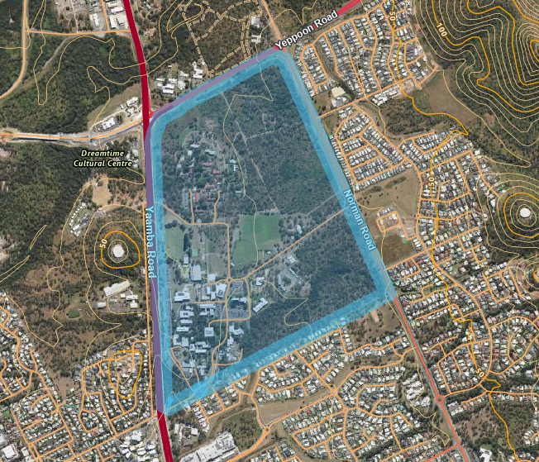

State Interests

A State Interest checklist was undertaken (Source Ref: D25/178497) and the following state interests and assessment criteria are relevant to this application:

State Interest | Assessment and action/resolution
State Transport and Infrastructure | The proposal is for management lots, resulting in 8 lots for various uses (note – the application does not apply for a material change of use) . Despite being adjoining State Transport Corridors, the proposed development for management lots do not trigger referral under the Planning Regulation 2017. However, the proposed development will not impact the ultimate development outcome given it is to facilitate future developments.

Relevant Site History & Preliminary Approval

On 15 December 2025, a PDA Development Permit for Material Change of Use for Outdoor Sport and Recreation and Park over the site was approved (DEV2025/1696).

Assessment & Key Issues

PDA Development Scheme Assessment
The proposed development is for the subdivision of the existing CQU Rockhampton Campus in order to establish management lots to facilitate future development outcomes. The proposed development is proposed in two stages, which is as follows:

Stage 1:
- 1 into 5 Lots:
  - Lot 10, 11, 12 and 13 (Existing CQU Uses)
  - Lot 70 (management lot)
Stage 2:
- Management Lot 70 subdivided into 4 Lots:
  - Lots 20, 21, 22, 23

The lots are proposed for the following ultimate outcomes:

- Lots 10, 11 and 12 to remain CQU Campus lots;
- Lot 13 to remain the CQU Child Care Centre;
- Lot 21 to become Rockhampton’s Sports park (in accordance with DEV2025/1696);
- Lots 20 and 22 are to be transferred into EDQ ownership for future development opportunities; and
- Lot 23 is for Council infrastructure.

These future lots will provide the opportunities for further development opportunities for the Rockhampton community. The facilitation of these management lots will not compromise or fetter the future development complying with the development scheme and is considered generally acceptable against the development scheme intentions.

Internal Referrals

6.1 Engineering
Comments and conditions regarding the proposal were received from engineering on 19 February 2026 (source ref: D26/25762).

6.2 Infrastructure Charges
The application was referred through to the Infrastructure Charges team for review (E26/48739). The Infrastructure Charges team has recommended the model condition be included on the approval. They further recommended that no charges be applied for Stage 1 – Stage 2 would potentially charges for the 2 new lots (20 and 22) (refer to the Rockhampton Charges Resolution No. 2 has a rate of $36,670.70 per lot).

While it is noted that a charge may be applicable for Stage 2, given the proposed reconfiguration is for a management lot only infrastructure charges are not considered applicable at this time. Charges will be payable for the future development of the lots created under Stage 2 and will be payable at that time.

PDA Development Conditions

Model conditions are recommended to be included in the approval for the proposed development.

Human Right Impact Assessment

In accordance with the Human Rights Act 2019 (HR Act), the human rights relevant to this decision are:
- Freedom of movement;
- Freedom of expression;
- Property rights (right to own property and not be arbitrarily deprived of property).

It is considered that a decision to approve the proposed development will not limit (or interfere with) the above listed human rights as;
- the development will not arbitrarily restrict the movement of people or limit the ability of people to move through open space;
- public notification of the application was not required;
- the development will not adversely affect how people may use their land.

Appendix 1 – Proposal plans

Stage 1:
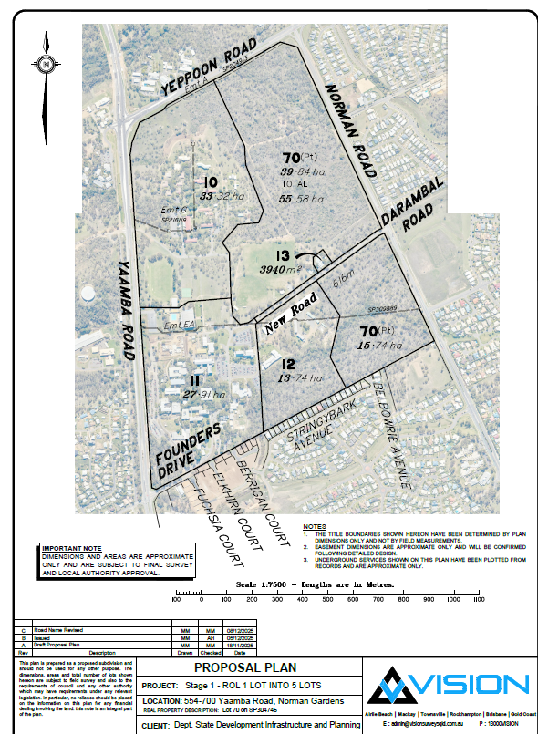

Stage 2:
