Assessment Report – Complex DA

Assessment Team
DA – Planner / Manager | Essen Joseph, Manager, New Growth
DA – Engineer | Sunny Wong, Director, Development Services
Decision Delegate | Carolyn Mellish, Director, New Growth

Recommendation

It is recommended:

- That the Delegate, under delegated authority and in accordance with the Economic Development Act 2012 (ED Act), approve the development application for a PDA Development Permit for Material Change of Use for Multiple dwelling (256 units), Hotel, Bar, Function facility and Food and drink outlet, and Building Work on a Heritage Place at 44 Balaclava Street and 93 Logan Road, Woolloongabba, subject to the Approved Plans and Documents and the PDA Development Conditions (refer Decision Notice at Source Ref D26/13897).

- That the PDA Decision Notice be provided to the applicant and the relevant local government, in accordance with section 89 of the ED Act.

Application Details

DA Reference No: | DEV2025/1691
Type of Approval: | Development Permit for Material Change of Use (MCU) and Building Works (BW) on a Heritage Place
Proposal Description: | MCU:  - Multiple dwelling (256 dwelling units)  - Hotel  - Bar  - Food and drink outlet  - Function facility  BW:  - BW on a Heritage Place  - Partial demolition of a Heritage Place
Applicant: | Broadway Projects Qld Pty Ltd ACN 652 220 865 Trustee Under Instrument 721957921 c/- Planning Initiatives
Properly Made Date: | 3 Oct 2025
Info Request Date: | 4 Nov 2025 (Source Ref E25/249370)
Info Request Response Date: | 8 Dec 2025 (Source Ref E25/278431)
Public Notification: | N/A
Decision Due Date: | 29 Jan 2026 (30 BD KPI)  12 Feb 2025 (40 BD statutory timeframe)

Property & Site Details
Priority Development Area: | Woolloongabba
Site Address: | 44 Balaclava Street and 93 Logan Road, Woolloongabba
Real Property Description: | Lot 76 RP11846 and Lot 50 RP217072
Area of Site: | 2,508m2

The site is:

- identified in Figure 1 and Figure 2 overleaf.
- located in the Woolloongabba PDA, within Precinct 2 – Logan Road;
- bounded by Balaclava St to the south, Logan Rd to the east / north-east, a car repair service to the north, and semi-industrial / commercial uses to the west / north-west;
- proximal to the Logan Rd hospitality node (identified as sub-area 2b), as well as a small park to the north;
- within an area undergoing urban renewal and change, as evidenced my mixed-use high-rise development to the east and south, as well as development approvals for the same in the neighbouring area (see Figure 3);
- characterised by the former Broadway Hotel building – a State-significant Heritage Place that is a defining feature of the site, as well as an iconic feature of the greater Woolloongabba area.

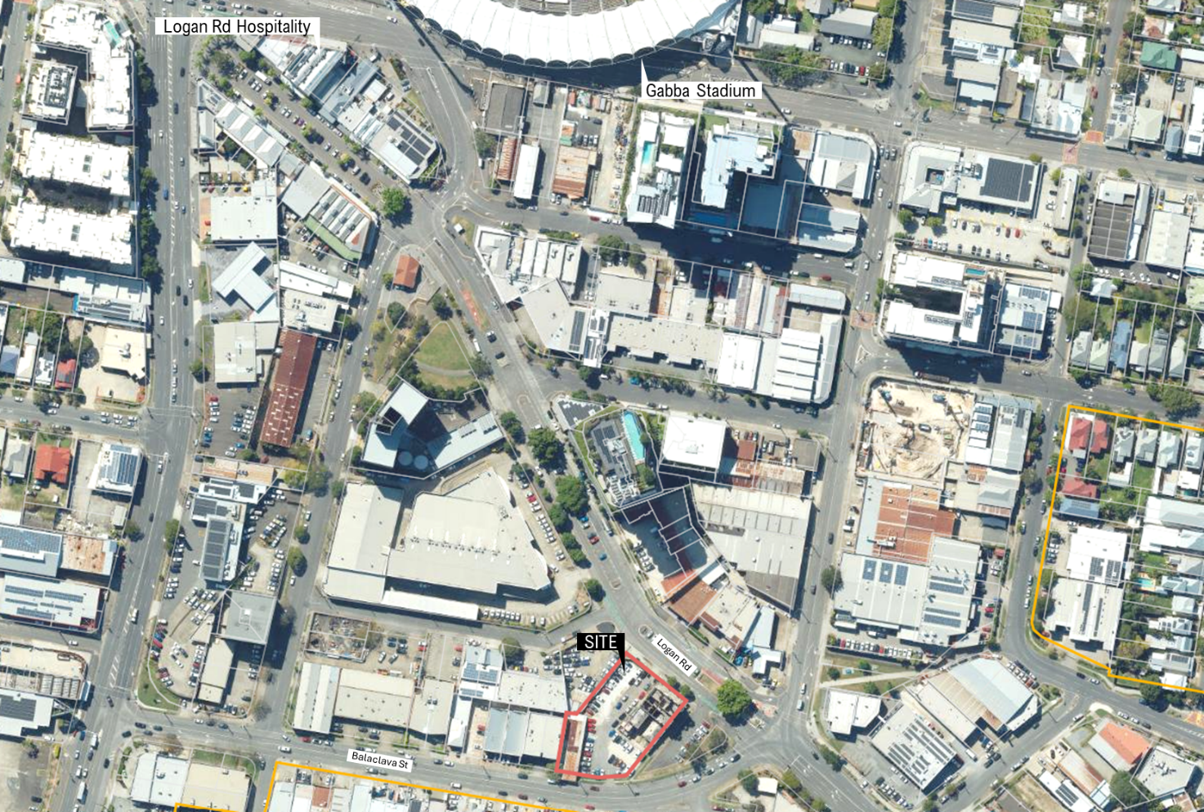
Figure 1 – Site plan (source: State Government Geoportal)
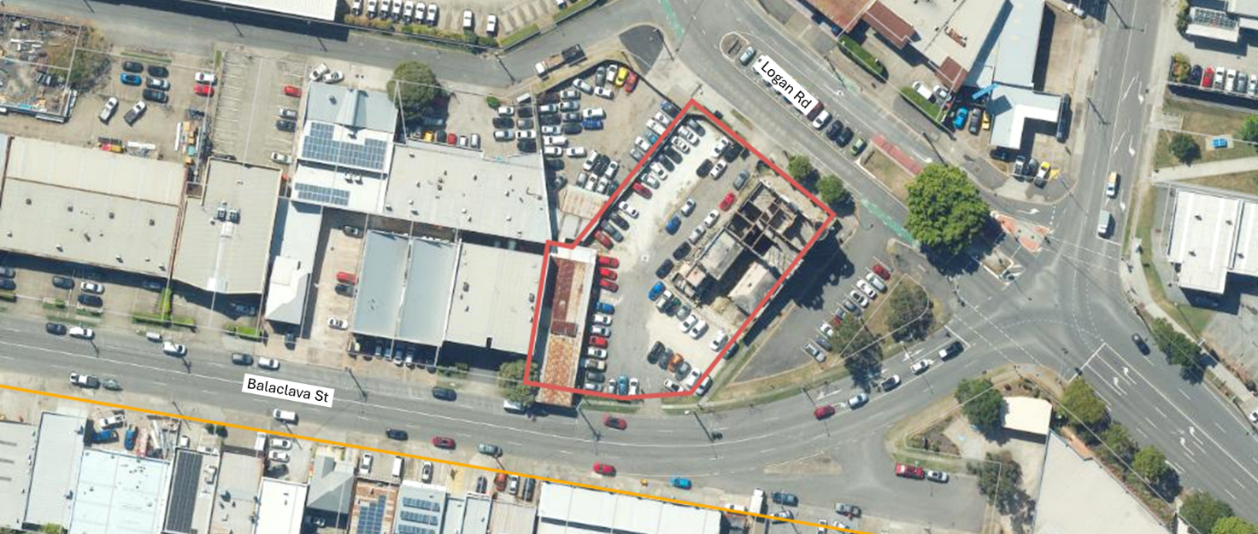
Figure 2 – Site plan – zoomed in (source: State Government Geoportal)
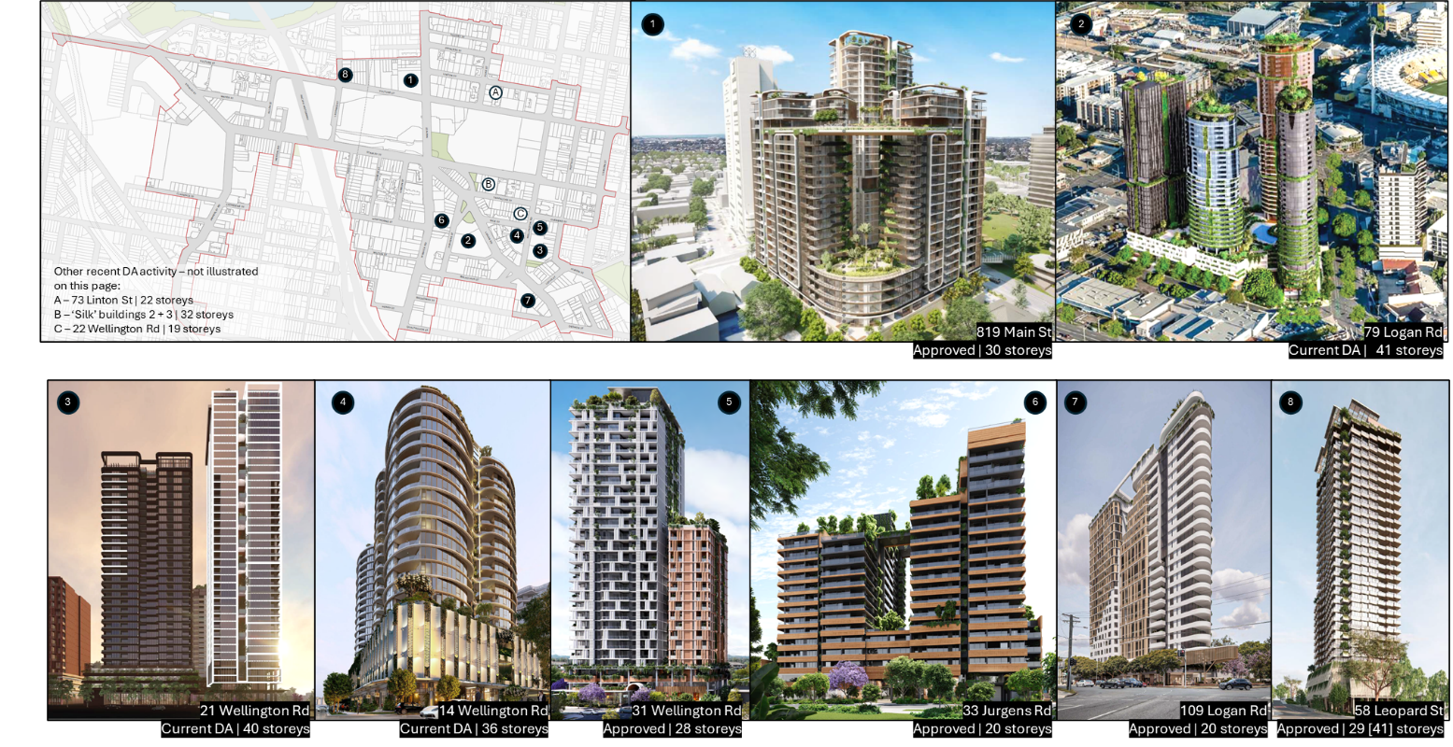

Figure 3 – Snapshot of development approved by Brisbane City Council (BCC) prior to PDA declaration (source: BCC Development i)
Notably, the site contains the former Broadway Hotel, a State-significant Heritage Place (illustrated in Figure 4) that operated as a privately-owned commercial hotel until its closure due to a fire in 2010. In 2018, it was heavily damaged in a second fire, followed by a third major fire in Jan 2026, and remains closed.

The Broadway Hotel Heritage Place is identified for its State heritage significance for the following reasons:

- The Broadway Hotel (1890) is important in demonstrating the evolution and pattern of Queensland's history, providing evidence of: the pattern of 1880s boom-era economic confidence, which led to a large increase in building throughout Queensland, most notably in Brisbane; and the evolution of the Woolloongabba-East Brisbane area in response to the growth of the railway and tramway systems.

- Standing prominently on its corner site on Logan Road, Brisbane, the Broadway Hotel is important for its aesthetic significance as a three-storey hotel in an elaborate, boom-era style. It is a landmark within the Woolloongabba townscape.

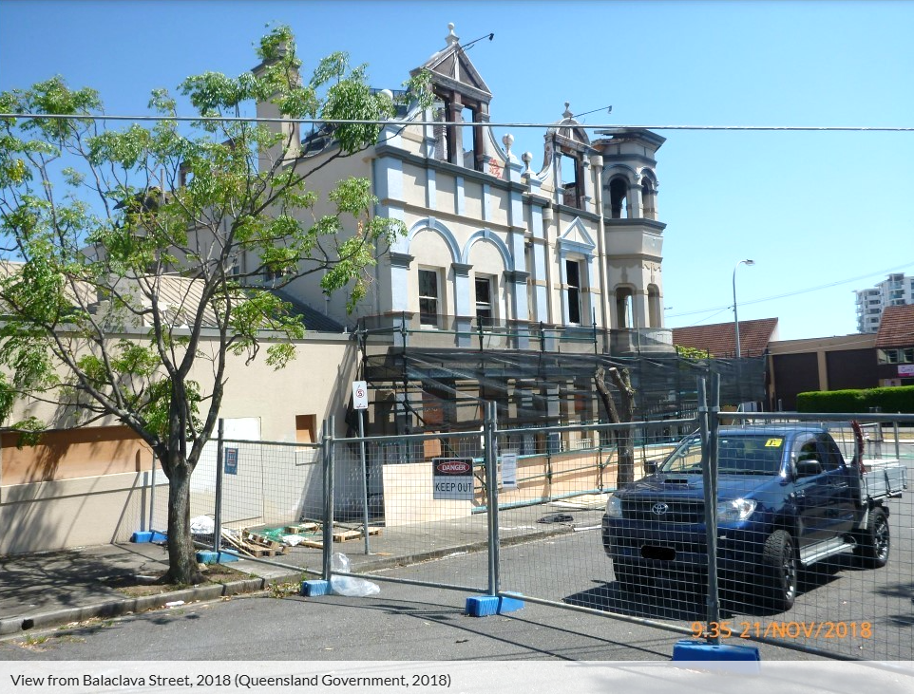
Figure 4 – View of the former Broadway Hotel from Balaclava St in Nov 2018 (source: https://apps.des.qld.gov.au/heritage-register/detail/?id=600354#, accessed 29 Jan 2025)

Proposal
The proposed development involves:

- Partial demolition of the Heritage Place, to the extent shown in the drawings recommended for approval, which have been reviewed by DETSI.
- Building additions adjoining the Heritage Place.
- The restoration and adaptive reuse of the Heritage Place, with land uses / activities being distributed within and adjoining the building as shown in Figure 9.
- The development of a residential tower adjoining and behind the Heritage Place, comprised of the following:
  - Land use: Multiple dwelling
  - Total number of storeys (above ground): 32
  - Basement: 3 storeys
  - Podium: 6 storeys
  - Communal open space: 2 storeys (Level 7 and Rooftop recreational areas)
  - Tower: 26 storeys (Levels 8 to 33)
  - Total dwellings: 256 (52x 1-bedroom dwellings, 179x 2-bedroom dwellings, 25x 3-bedroom dwellings)
  - Activation of Balaclava St through the placement / design of a ground floor residential lobby and parts of the restored Heritage Place
  - Activation of Logan Rd through the placement / design of a Food and drink outlet and parts of the restored Heritage Place
  - Residential, visitor, and non-residential parking access via Balaclava St
  - Service vehicle access via Logan Rd
  - 276 total car parking spaces (including 43 visitor spaces)
  - 394 bicycle parking spaces (including 70 visitor spaces)
The general layout and form of the proposed development is presented in
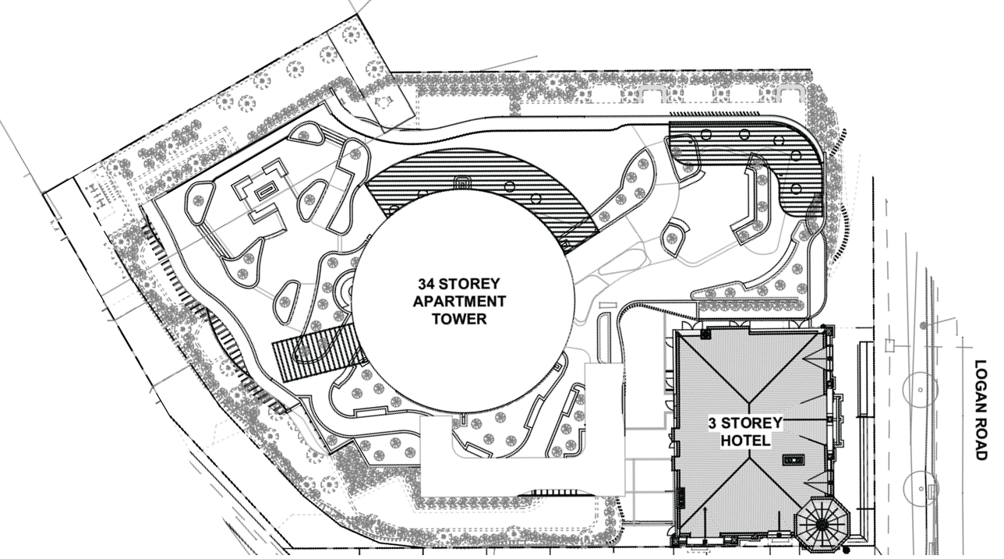
Figure 5 – Footprint of hotel and proposed residential tower (source: application material)
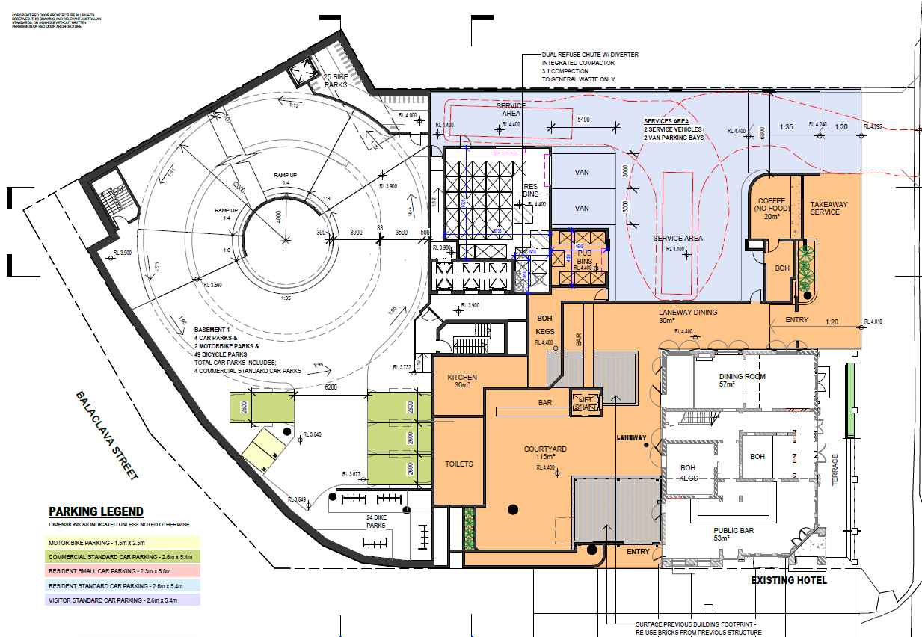
Figure 6 – Ground floor plan - hotel level (source: application material)
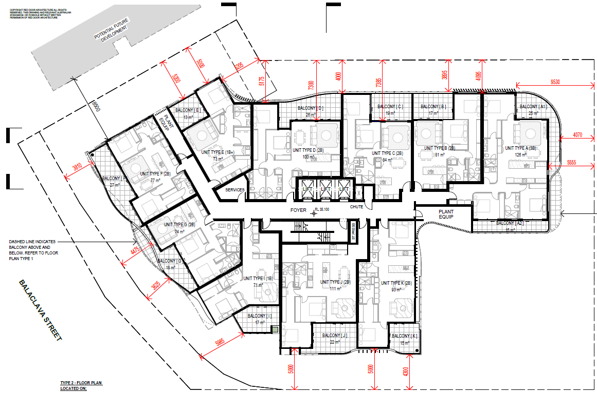
Figure 7 – Typical floor plan (source: application material)
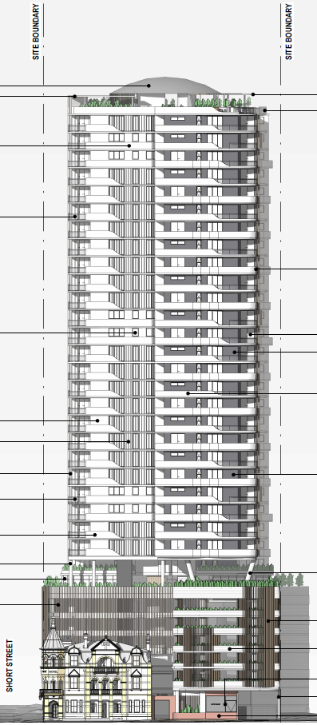 | 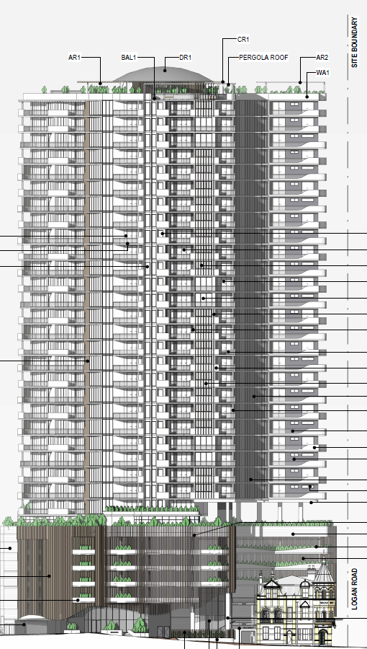
Logan Rd Elevation | Balaclava St Elevation
Figure 8 – Elevations of proposed development (source: application material)
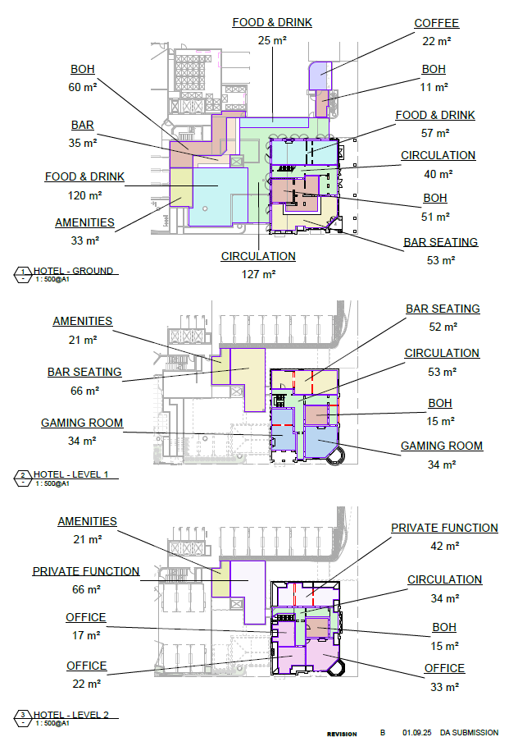
Figure 9 – Uses / activities within the restored Heritage Place (source: application material)

State Interests

The State’s Development Assessment Mapping System (DAMS) identifies the site as containing a Queensland Heritage Place. The application was accordingly referred to the Department of Environment, Tourism, Science, and Innovation (DETSI), which is responsible for State heritage matters.

As discussed later in this report, DETSI input was sought in relation to the information request and conditions of approval.

As DETSI input has been factored into this assessment and conditions have been prepared accordingly, State interest in connection with the Queensland Heritage Place are satisfied.

Relevant Site History & Preliminary Approval
As outlined in the application material (Source Ref WR25/29245), the project was discussed with the State Assessment and Referral Agency (SARA) prior to PDA declaration. In general, SARA was supportive of the proposed development and comments are consistent with subsequent DETSI comments provided as part of this application.

Assessment Provisions
As per section 87 of the Economic Development Act 2012 (the Act), the MEDQ must consider the following in making a decision about the application:

Matters to consider | Applicable
(a)the main purpose of this Act; and | Yes
(b)any relevant State interest; and | Yes
(c)any submissions made to it about the application, during the submission period; and | No
(d)the following instruments—  (i)for an application for development in, or PDA-associated development for, a provisional priority development area—  (A)if a provisional land use plan is in effect for the area when the application is decided—the provisional land use plan; or  (B)otherwise—the draft provisional land use plan for the area;  (ii)for an application for development in, or PDA-associated development for, another priority development area—  (A)if a development scheme is in effect for the area when the application is decided—the development scheme; or  (B)if a development scheme is not in effect for the area when the application is decided, but there is a proposed development scheme for the area—the interim land use plan for the area and the proposed development scheme; or  (C)if a development scheme is not in effect for the area when the application is decided and there is no proposed development scheme for the area—the interim land use plan for the area; and | Yes
(e)any PDA preliminary approval in force for the relevant land; and | No
(f)any preliminary approval under the Planning Act in force for the relevant land; and | No
(g)if the application is for development in a place renewal area—  (i)a place renewal framework in effect for the area under part 4A when the application is decided; and  (ii)any advice sought by MEDQ in relation to the place renewal framework or the application. | No

Purpose of the Act
Section 3 of the Act identifies the following as its purpose:

(1) The main purpose of this Act is to facilitate the following in the State—
(a) economic development;
(b) development for community purposes;
(c) the provision of diverse housing, including, for example, social housing and affordable housing;
(d) the provision of premises for commercial or industrial uses.
(2) In this section—
diverse housing means a range of housing to meet a variety of community needs, including, for example, housing of different size, type, price, built form, density, cost, adaptability and tenure.
provision, of diverse housing or premises, includes the funding, facilitation, delivery, supply and ownership of the housing or premises.
The proposed development and the recommendation contained in this report advances the purpose of the Act by supporting economic development, the advancement of community purposes through the restoration of a Queensland Heritage Place, and the delivery of diverse housing and commercial uses.

State Interests
The State’s Development Assessment Mapping System (DAMS) identifies the site as containing a Queensland Heritage Place. The application was accordingly referred to the Department of Environment, Tourism, Science, and Innovation (DETSI), which is responsible for State heritage matters.

As discussed later in this report, DETSI input was sought in relation to the information request and conditions of approval.

As DETSI input has been factored into this assessment and conditions have been prepared accordingly, State interest in connection with the Queensland Heritage Place are satisfied.

Woolloongabba PDA Development Scheme
For a full assessment against the provisions of the Scheme and the Flood Overlay Code of the Brisbane City Plan 2014 (statutorily called up by the Scheme), refer to Source document D26/6941.

VISION

The proposed development aligns with the following key aspects of the PDA Vision:

Woolloongabba is a destination for Brisbane’s inner south as a place to live, work, play, learn, and stay. Residents and visitors are provided an array of day and night experiences, including a new Gabba Entertainment Precinct…

The PDA focuses on providing increased housing supply that will deliver a choice of homes. Housing within the PDA is supported by retail, dining, entertainment and community uses that address the needs of local communities.

Existing community spaces and places of value are celebrated and renewed, enhancing Woolloongabba’s identity and sense of place. New open space areas and public realm improvements will add greenery and improve connectivity within the PDA and to areas outside the PDA. In combination with retail, dining and community uses these spaces will provide opportunities for community enjoyment, civic engagement and urban amenity, supporting urban living.
PDA-WIDE CRITERIA

The proposed development complies with the majority of the PDA-wide criteria, including (but not limited to the following):

2.5.1 Connections and movement
Development…
2. facilitates a movement network that improves connectivity:
a. to key destinations within the PDA and the surrounding area, and
b. between existing and future public transport infrastructure, including CRR, and the bus network

2.5.2 Built form

Development…

1. responds to the site characteristics and context,
2. sensitively interfaces with heritage, character, streetscapes and the public realm,

2.5.3 Public Realm

Development…

1. creates a public realm that:
a. is connected and safe,
b. is universally accessible,
c. is a landscaped, attractive subtropical environment,
d. retains existing shade trees along road frontages as far as practicable,
e. ensures any trees removed during development are replaced with advanced stock of suitable tree species,
f. supports a wide range of passive and active recreational and community activities,
g. includes placemaking elements,
h. ensures servicing elements are located and designed to avoid or minimise impacts.

2.5.4 Heritage and Character

1. provides for the conservation and adaptive re-use of heritage places within the PDA in a way which:
a. is compatible with their cultural heritage significance and does not detract from their interpretation and appreciation, while enabling new uses,
b. maintains or enhances the historic built form, character, place features, and setting of the heritage place,
c. does not compromise the building fabric or structural integrity, including during construction,
2. successfully integrates with elements of heritage significance through:
a. enabling the heritage place to be a prominent feature,
b. contemporary design and avoiding imitation design elements.
2.5.6 Responsive Design

Development addresses:
1. natural hazards,
2. appropriately responds to flooding constraints,

In relation to flooding, it is noted that the proposed development satisfies the provisions of the Flood Overlay Code of the Brisbane City Plan 2014 (the City Plan), which is statutorily referenced by the Scheme for assessment purposes.

However, the proposed development does not satisfy the following PDA-wide criteria:

Criteria | Assessment
2.5.2 Built form
4. provides visual privacy for both occupants and neighbours, | Does Not Comply – Sufficient Grounds  The 4-5m tower setback to the north would result in 8-10m building separation if the same setback were to be adopted by the adjoining development site. Similarly, the 5m tower setback to the north-west would result in approximately 10m building separation. Building separation at both boundaries would be below the 18m building separation sought by the acceptable outcomes outlined in the Scheme.  These setbacks / building separation result in lower levels of amenity than planned for the future residents of the subject site, as well as adjoining sites, having regard for access to natural light, ventilation, outlook, and privacy.  The lesser setbacks / building separation also prejudice the ability of the adjoining site to develop in a manner that complies with the acceptable outcomes identified in the Scheme.  However, taking into account the site constraints placed on the building footprint by the Heritage Place, as well as the importance of leveraging Heritage Place restoration through the redevelopment, it is considered that there are sufficient grounds to justify approving the development, despite its conflict with the Scheme. The proposed boundary setbacks and building design were agreed to by the Chief Infrastructure and Planning Officer.
7. mitigates the impact of building mass by ensuring:
a. lower levels are designed to respond to human scale,
b. visual interest and articulation,
c. fine-grained design and architectural detailing at lower levels contributing to the character of the streetscape,
d. car parking is not visually dominant,
e. vehicle impacts on adjacent properties, are minimised,
f. visual impact of servicing areas are minimised.
2.5.5 Impacts and Amenity
10. does not unreasonably prejudice the development potential of adjoining or proximate sites,

Sufficient Grounds

The proposed development involves the restoration of a Queensland Heritage Place that has been substantially damaged by 3 fires, and which may otherwise be unable to be restored without leveraging the redevelopment potential of the site.

The level of significance of the Heritage Place and its importance historically and culturally to the Woolloongabba and wider Brisbane and Queensland communities is accepted as sufficient grounds to approve the development, despite its conflict with the Scheme. This is especially the case within the constraints of the subject site, which contains limited area / dimensions to support alternative forms of development.

PRECINCT PROVISIONS

As demonstrated in Appendix A, the proposed development complies with the precinct provisions outlined in the Scheme, including (but not limited to) the following:

2.6.2.1 Precinct Intent

Precinct 2 will experience significant urban renewal, developing into a mixed-use neighbourhood.

Precinct 2 has a predominant focus on new homes, capitalising on the precinct’s improved urban amenity and proximity to public transport. At street-level, frontages of buildings along Logan Road, Ipswich Road, Stanley Street and Wellington Road are activated with non-residential land uses and conveniences.

SCHEDULE 3 – CAR PARKING

As per Schedule 3, the maximum allowable parking for uses other than Multiple dwelling is 1 space per 300m2 GFA. As the total non-residential GFA is 642m2, the proposed development can have up to 2 parking spaces.

The proposed development may provide the following car resident parking as per the rates identified in Schedule 3:
- 52x 1-bedroom dwellings – maximum 0.5 space per 1 bedroom dwelling, equating to 26 parking spaces
- 179x 2-bedroom dwellings – maximum 1 space per 2-bedroom dwelling, equating to 179 parking spaces
- 25x 3-bedroom dwellings – maximum 1.5 spaces per 3-bedroom dwelling, equating to 38 parking spaces
- Total allowable parking – 243 spaces

The proposed development provides a total of 243 spaces, including both residential and non-residential parking. As such, the proposed development complies with the maximum parking rates.

In relation to visitor parking, 0.15 visitor spaces are required per dwelling. Given there are 256 dwellings applied for, 38 spaces are required. The development complies with this requirement, providing 43 spaces.

Internal Referrals

Engineering
Draft conditions and endorsement of the Flood Overlay Code assessment was received from EDQ engineers as per Source documents E26/20001 and E26/20009.

Infrastructure Charges
Conditions in relation to infrastructure charging were received from EDQ’s infrastructure planners on INSERT (Source Ref E26/19985).

External Referrals
The application was referred for review to DETSI prior to the issuance of the information request, and prior to the issuance of draft conditions to the applicant.

At the time of information request, matters of detail were raised by DETSI and integrated into EDQ’s information request.

At the time of condition drafting, DETSI provided comments, including the State Assessment and referral Agency’s draft conditions. Draft conditions were refined on this basis, principally in relation to vibration and construction management matters, to ensure the Heritage Place is not inadvertently / inappropriately damaged.

Se Source documents E26/19975 and E26/19999 for details.

Draft Conditions
As a courtesy, and to ensure there are no unforeseen issues with conditions of approval, draft conditions were sent to the applicant for review on 22 Jan 2026 (Source Ref E26/20002). No formal response was received; however, a meeting between Carolyn Mellish (Director, New Growth) and the developer was held at which agreement to the conditions was provided.

Notification and Submissions
In accordance with the PDA Development Scheme, notification of the development application was not required.

Human Rights Impact Assessment

In accordance with the Human Rights Act 2019 (HR Act), the human rights relevant to this decision are:

- Freedom of movement;
- Freedom of expression;
- Property rights (right to own property and not be arbitrarily deprived of property).

It is considered that a decision to approve the proposed development will not limit (or interfere with) the above listed human rights as:

- the development will not arbitrarily restrict the movement of people or limit the ability of people to move through open space;
- public notification of the application was not required;
- the development will not adversely affect how people may use their land.

Conclusion
It is recommended that the proposed development be approved, subject to conditions, as per the recommendation outlined at the outset of this report.

The matters raised in the information request were generally satisfied by the response.
E.g. 825 Stanley St (EDQ Ref DEV2025/1791), 79 Logan Rd (BCC Ref A006340456), 109 Logan Rd (BCC Ref A006335148), 14 Wellington Rd (BCC Ref A006350223) and 44 Ipswich St (BCC Ref A006150645).
Information sourced form the State government heritage citation, available at https://apps.des.qld.gov.au/heritage-register/detail/?id=600354#.
The Level 7 and Rooftop recreation areas are not regarded as a ‘storey’ due to the definition of the term contained in the Scheme.
Footnote 18: Cultural heritage significance has the meaning given to it under the Schedule Dictionary of the Queensland Heritage Act 1992.
Subject to detailed assessment, larger setbacks may be achieved at the adjoining site/s. However, for current assessment purposes, it is assumed at this time that equivalent setbacks will be delivered on adjoining sites.
Footnote 11: For example, towers may be setback from lower levels of buildings to avoid the perception of visual bulk.
Footnote 29: Development potential means what can reasonable be achieved under this Development Scheme or existing development approvals.

