DEV2025/1691
DETAILED ASSESSMENT –
WOOLLOONGABBA PDA DEVELOPMENT SCHEME

This document provides an assessment of the proposed development subject to development application DEV2025/1691 against the relevant provisions of the Woolloongabba PDA Development Scheme (the ‘Scheme’), dated October 2025.

Vision
RELEVANT VISION STATEMENT/S | ASSESSMENT
OVERARCHING STATEMENTS
Woolloongabba is a destination for Brisbane’s inner south as a place to live, work, play, learn, and stay. Residents and visitors are provided an array of day and night experiences, including a new Gabba Entertainment Precinct. | Complies  The proposed development will contribute to the establishment of Woolloongabba as:  - a desirable place to live, noting it will deliver 256 new residential dwellings; and  - a destination for day and night activity, as it will enable the restoration of a State significant heritage building, re-establishing its use a s a Hotel.
Within the PDA, the role of the health and knowledge cluster anchored by the Mater and Children’s Hospitals is strengthened and supported by tertiary education and research facilities, and more homes in proximity to major employment, education and transport services. | Not applicable
The PDA focuses on providing increased housing supply that will deliver a choice of homes. Housing within the PDA is supported by retail, dining, entertainment and community uses that address the needs of local communities. | Complies  The proposed development will contribute to unlocking housing supply, while also delivering dining and entertainment opportunities.
Existing community spaces and places of value are celebrated and renewed, enhancing Woolloongabba’s identity and sense of place. New open space areas and public realm improvements will add greenery and improve connectivity within the PDA and to areas outside the PDA. In combination with retail, dining and community uses these spaces will provide opportunities for community enjoyment, civic engagement and urban amenity, supporting urban living. | Complies  The former Broadway Hotel is a Stage significant Heritage Place and makes a notable contribution to the identity of Woolloongabba as a place. Its preservation and restoration after three fires represents a significant contribution to the sense of place that is intended for the PDA.  The restoration of the Heritage Place is recognised as sufficient grounds for approving the proposed development, despite its conflicts with the Scheme.
VISION ELEMENTS
Development:
1. is transit oriented and well-integrated with existing and future public transport infrastructure, including infrastructure associated with CRR, and the bus network, | Complies  The development leverages the proximity of existing and future public transport by providing appropriate density in a well-serviced location.
2. delivers a mix of uses, supporting:  a. a range of homes to meet the life-cycle needs of a diverse population,  b. employment and entertainment, including health and innovation,  c. social infrastructure, including community and educational facilities, | Complies  The development includes a mix of 1, 2, and 3-bedroom dwelling units , catering for a range of household types, and also includes a Hotel, Bar, Food and drink outlet, and Function facility.
3. enhances and protects the efficient operation, function and expansion of health and knowledge uses at Mater Hill, and nearby health and education facilities, including the Queensland Children’s Hospital, | Not applicable
4. supports the current operation of the Gabba Stadium and enables the future Gabba Entertainment Precinct, | Not applicable
5. enables a connected and safe movement network within the PDA and to surrounding areas, integrating wayfinding and active transport and access to public transport infrastructure, | Complies  The proposed development provides footpath and streetscape upgrades in accordance with the Infrastructure Design Planning Scheme Policy (PSP) contained in the Brisbane City Plan 2014 (the ‘City Plan’).
6. supports and protects the functional requirements of major transport infrastructure and corridors, including State and local government controlled roads and tunnels, | Complies  The proposed development is in accordance with planning for transport corridors.
7. is designed to respond to Brisbane’s climate and identity through subtropical design a quality public realm with landscaping that contributes to mitigating urban heat, | Complies  The proposed development provides:  - landscaping on 6 levels, overhanging Logan Rd, contributing to subtropical design outcomes, as well as urban heat island mitigation;  - generous landscaping on the recreational decks on Level 7 and the rooftop, promoting occupation of outdoor spaces and leveraging Brisbane’s climate;  - plans for potential future open space at the corner of Balaclava St and Logan Rd, relying on the conversion of surplus road reserve into open space.
8. is responsive and resilient to physical constraints, and | Complies  The proposed development is responsive to flood constraints, placing access out of flood affected areas, and placing servicing areas above the requisite flood planning levels. See the assessment against the Flood Overlay Code contained in Source document D26/6941.
9. provides for the conservation and successful integration of heritage places, including through adaptive re-use. | Complies  Th proposed development prominently features the restoration and reuse of a State Heritage Place.

Structural Elements + Building Heights
The site is located at the corner of Balaclava St and Logan Rd, as presented in Figure 1 below. The location adjoins planned open space, as well as the creek to cliffs corridor, which is intended to be embellished as a green, historical corridor.
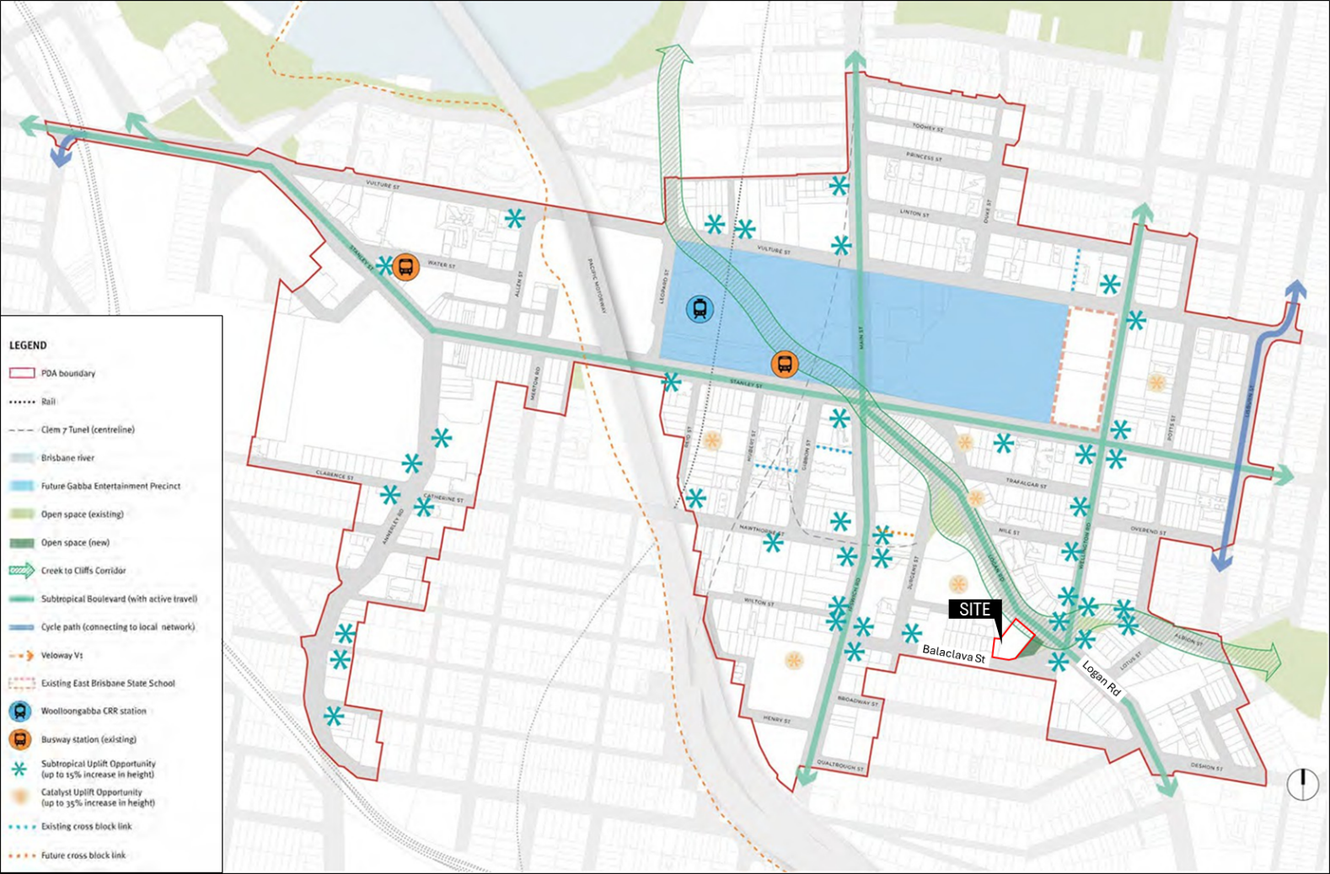
Figure 1 – Site location within the context of Map 2: Woolloongabba PDA Structural Elements Plan
As shown in Figure 2, the site is within an area where 35 storey development is planned (subject to compliance with all elements of the Scheme).
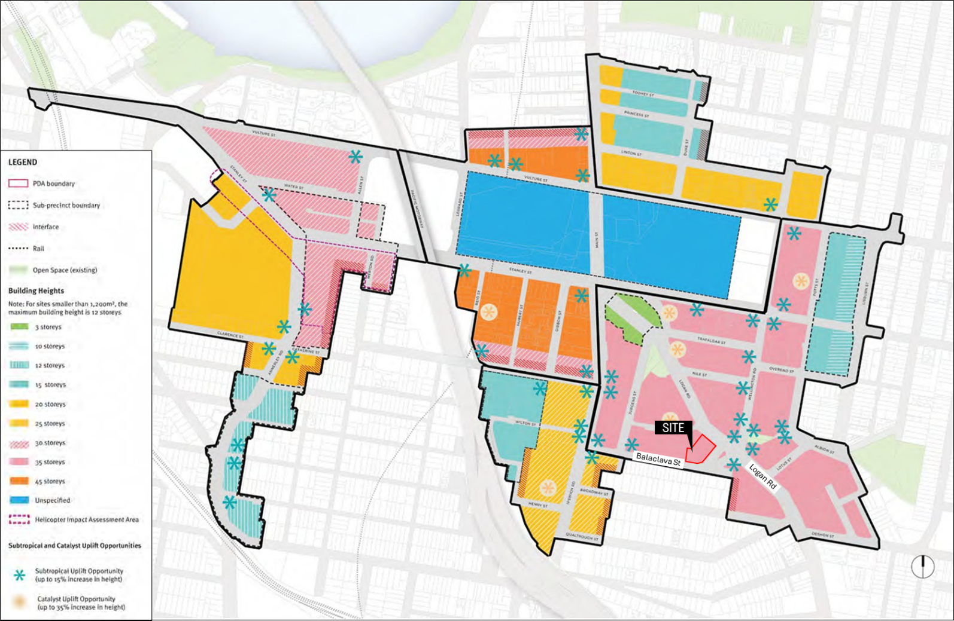
Figure 2 – Site location within the context of Map 3: Building Height Plan

As shown in Figure 3, setbacks on the site are intended to be informed by the existing setbacks - in this case, the Broadway Hotel Heritage Place.
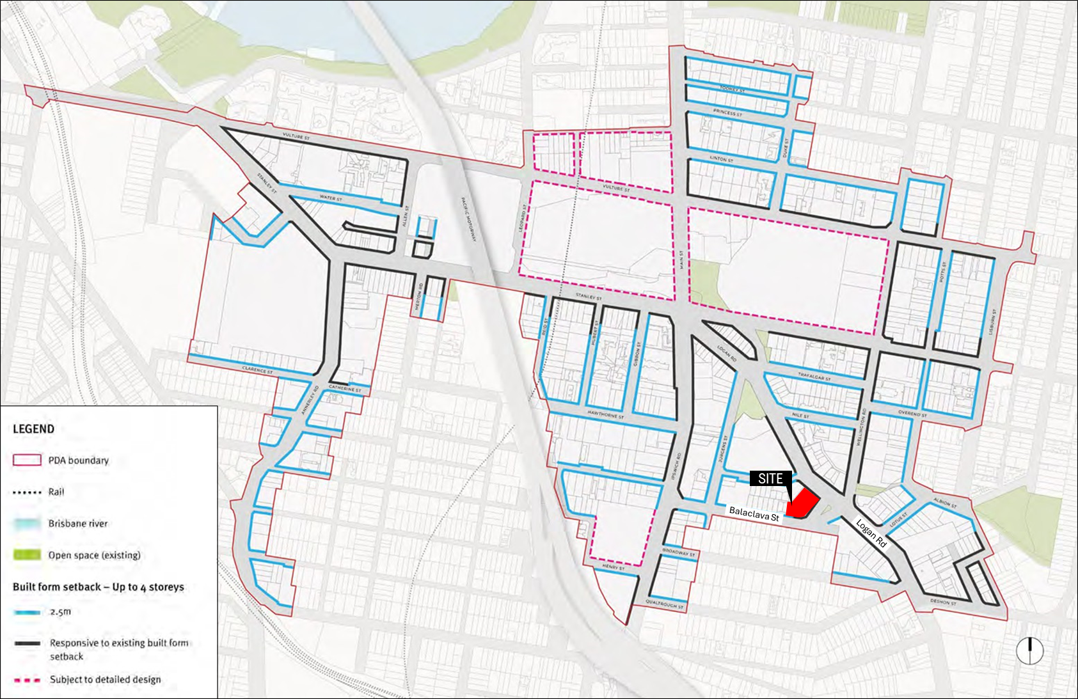
Figure 3 – Site location within the context of Map 4: Road Frontage Setback Plan

As illustrated in Figure 4, the building lines on both logan Rd and Balaclava St respond to the setbacks of the Broadway Hotel.
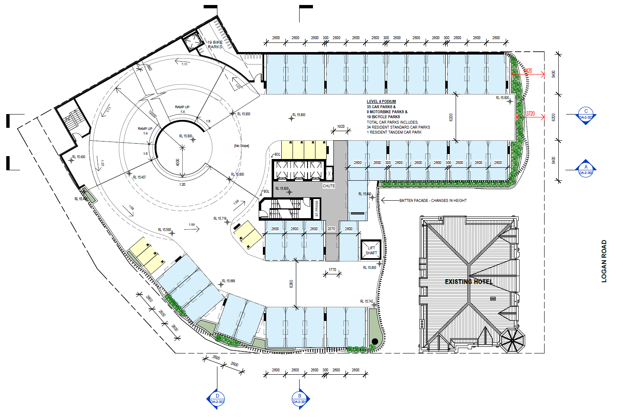
Figure 4 – Plan showing that building line responds to the setbacks associated with the Heritage Place (source: application material)

PDA-wide Criteria

2.5.1 Connections and movement
PDA-WIDE CRITERIA | ASSESSMENT
Development:
1. contributes to active transport opportunities and amenity along subtropical boulevards, including Stanley Street, | Complies  The proposed development:  - provides footpath and streetscape upgrades in accordance with the Infrastructure PSP contained in the City Plan;  - relocates and reinstates an existing bus stop;  - integrates with existing and future transport networks; and  - will be required to provide continuous awnings along its frontages, other than adjoining the heritage place and the service vehicle entry on Logan Rd.
2. facilitates a movement network that improves connectivity:
a. to key destinations within the PDA and the surrounding area, and
b. between existing and future public transport infrastructure, including CRR, and the bus network,
3. provides for streetscapes and minimum verge widths that support urban greening,
4. provides streetscape and public realm treatments along key routes that offer weather protection for pedestrians.

2.5.2 Built form
PDA-WIDE CRITERIA | ASSESSMENT
Development:
1. responds to the site characteristics and context, | Complies  The proposed development:  - restores a State-significant Heritage Place, and is designed to celebrate its visual prominence at the intersection of Balaclava St and Logan Rd; and  - features a podium design that, as per the submitted Heritage Impact Assessment, is designed to treat the podium as a backdrop to the visually prominent Heritage Place.
2. sensitively interfaces with heritage, character, streetscapes and the public realm,
3. mitigates the visual bulk and scale of buildings and maintains key views to heritage places and major destinations,
4. provides visual privacy for both occupants and neighbours, | Sufficient grounds  The tower levels of the proposed development are setback approximately 4-5 metres, whereas the Scheme identifies acceptable outcomes that would suggest 9m setbacks as an appropriate way of addressing privacy (among other things). The reduced setbacks are accepted as appropriate under the circumstances, as the location of the heritage place dictates where the tower levels can be placed, and the restoration of the State-significant Heritage Place provides sufficient grounds for approving the development, despite its conflict with the Scheme.
5. integrates building services into the design, ensuring these features do not visually detract from the building or negatively impact amenity, | Complies  Other than essential booster and transformer facilities, the proposed development locates services behind the building.
6. minimises the number and scale of access points for vehicles (private and servicing), | Complies  The proposed development locates the primary point of access on Balaclava St for residential, commercial, and visitor parking, and provides a service vehicle access point via Logan Rd, which cannot be consolidated with the Balaclava St access point due to level changes.
7. mitigates the impact of building mass by ensuring:  a. lower levels are designed to respond to human scale,  b. visual interest and articulation,  c. fine-grained design and architectural detailing at lower levels contributing to the character of the streetscape,  d. car parking is not visually dominant,  e. vehicle impacts on adjacent properties, are minimised,  f. visual impact of servicing areas are minimised. | Sufficient grounds  The mass of the podium is significant, relative to the acceptable outcomes specified in the Scheme, as well as the proportions of the Heritage Place. However, it is noted that:  - the building footprint (both above and below ground) is constrained by the Heritage Place;  - to mitigate the prominence of the podium, the design provides a muted built form on the first 6 levels to act as a backdrop to the Heritage Place;  - sufficient grounds exist for approving the development despite its conflict with the Scheme due to the community benefit associated with the restoration of the State-significant Heritage Place.
8. responds to Brisbane’s subtropical climate and improves urban amenity by:  a. adopting design strategies that leverage subtropical climate conditions to reduce the need for mechanical heating, cooling and lighting,  b. maximising access to natural light and air flow,  c. incorporating generous outdoor spaces and landscaping, on ground levels, podiums, roofs, balconies, terraces, and/or edges of buildings,  d. enabling light penetration to the public realm,  e. defining and addressing the street and public realm, creating active frontages that provide a visual connection between public and private spaces,  f. establishing landscaping, shade and shelter along building edges,  g. providing awnings along key streetscapes. | Complies  The proposed development provides direct access to light and ventilation to all dwelling units, as well as appropriately sized balconies that promote the use of outdoor spaces. Additionally, the proposed development plans for future enhancements of adjoining public space. Specifically, the design seeks to leverage future opportunities for al fresco dining and events in a potentially future open space area, contributing to ‘life on the street,’ should the open space upgrades be realised in future.
9. mitigates potential adverse amenity impacts between areas of differing scale and form, | Not applicable  The proposed development is not located in a sensitive interface area and does not adjoin any low-rise residential development.
10. ensures towers feature distinctive architectural form covering no more than 75% of the area of the podium, | Complies  - The tower displays a distinctive architectural form, featuring:  - a building footprint that is shaped by the Heritage Place; and  - curvilinear balconies that serve as an identifying feature of the development.  - As shown in Figure 5, the tower site cover is 1,330 m2. As per the drawing entitled ‘Area Plan – Site Cover,’ dated 27.11.2025, the site cover of the podium (including the Heritage Place) is 2,189m2. Based on these measurements, the tower is approximately 60.8% of the area of the podium.
11. providing frontages overlooking streetscapes and public realm, | Complies  Ground level frontages provide overlooking of the adjoining streetscape.
12. provides private open space for residential uses that:  a. is directly accessible from primary living areas,  b. accommodates furniture and encourage use, and  c maximises privacy, | Complies  The proposed development provides private open spaces that are directly accessible from living areas, which are capable of accommodating furniture and provide an acceptable level of privacy.
13. provides universally accessible communal open space that:  a. is a combination of ground level, vertically distributed and/or roof top settings,  b. includes generous landscaping, including tree planting, and  c. has good access to natural light and ventilation to support landscaping growth | Complies  The proposed development provides well-designed communal open space on the podium-top and rooftop, featuring generous landscaping, which is appropriately sited to support growth. A more detailed landscape design will also be required as a condition of approval.
14. incorporates CPTED principles, including passive surveillance of streets and publicly accessible spaces, | Complies  The proposed development provides overlooking of both its street frontage via activated spaces on ground level, which provide overlooking.
15. where involving lot reconfiguration:  a. ensures site dimensions and areas of all lots are suitable for future development in accordance with PDA development requirements, or  b. is limited to boundary re-alignment that does not create any adverse impacts. | Not applicable  The proposed development does not feature lot reconfiguration.

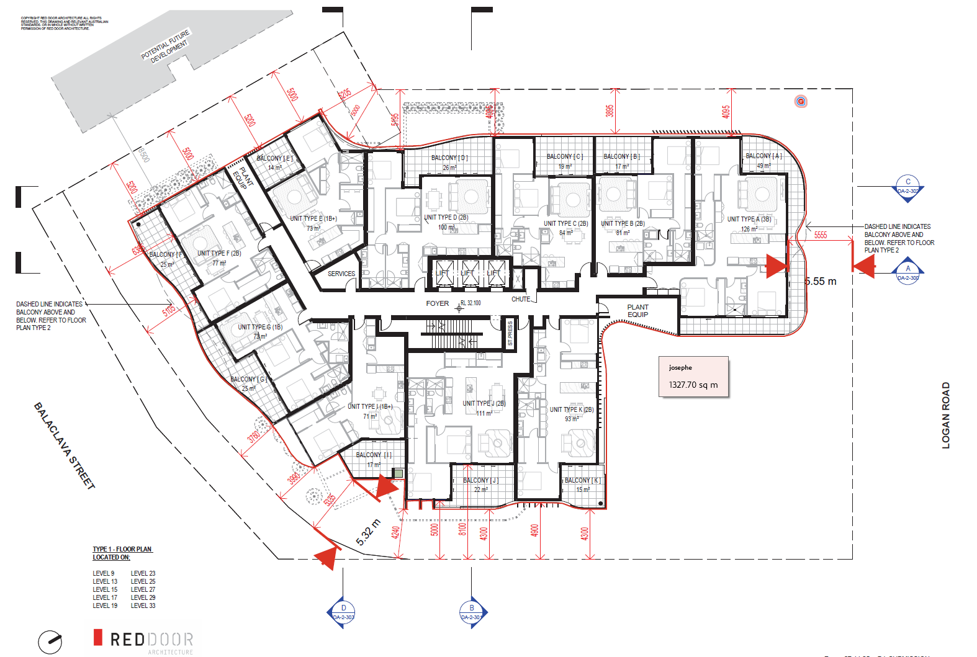

Figure 5 – Tower site cover (source: adapted from the application material)

Table 2: Acceptable Outcomes
ACCEPTABLE OUTCOMES |  | ASSESSMENT
Building height | - On a site with an area less than 1,200m2: 12 storeys.  - Otherwise, as per Map 3 | Complies  The proposed development features 33-storeys in an area where 35 storeys may be accommodated.
Podium height | - On or adjoining a heritage place - consistent with and complements the height of heritage façades, including the predominant form and scale within the streetscape.  - Otherwise - up to 4 storeys  Note: podium height not applicable to building typologies that do not rely on the use of a podium and tower. | Sufficient grounds  The mass of the podium is significant and does not respond to the proportions of the Heritage Place. However, it is noted that:  - the building footprint (both above and below ground) is constrained by the Heritage Place;  - to mitigate the prominence of the podium, the design provides a muted built form on the first 6 levels to act as a backdrop to the Heritage Place;  - sufficient grounds exist for approving the development despite its conflict with the Scheme due to the community benefit associated with the restoration of the State-significant Heritage Place.
Street frontage setbacks | - Up to 4 storeys – refer to Map 4  - Above 4 storeys – 6m | Complies  The proposed development maintains approximately the same building line as the Heritage Place.
Side and/or rear setbacks | Up to 4 storeys:  - 0m for built to boundary  - minimum 6m to habitable rooms,  - minimum 3m to balconies; or  - minimum 3m to non-habitable rooms.  Note:  - Greater side and rear setbacks may be required for the 'Interface Areas' shown on Map 3 or identified in Sub-precinct 1a.  - Building separation requirements may necessitate greater setbacks | Complies  Up to 4 storeys, the proposed development features a built-to-boundary building design, which is consistent with the 0m setback allowed by this provision.
Side and/or rear setbacks | Towers:  - minimum 6m, or  - minimum 9m – if the windows of habitable rooms are located along that boundary. | Sufficient grounds  The following non-compliances are noted:  - Levels 5 and 6 are built to boundary;  - Level 7 provides a 3.5m setback to the north-west;  - Level 8 provides a 5 – 5.2m setback to the north-west, and a 5.7m setback to the north;  - Levels 9 and above provide a 5 – 5.2m setback to the north-west and a 4 – 5.2m setback to the north.  As previously discussed, however, sufficient grounds have been established to approve the development, despite its conflict with the Scheme.
Tower floor plates | - For residential development or mixed use development involving residential uses – up to 1,200m2, or  - For non-residential development – up to 2,000m2. | Does not comply  At approximately 1,330m2, the tower floor plate is larger than the 1,200m2 parameter envisaged by this outcome.  However, the proposed development complies with the PDA-wide criterion that corresponds to this provision.
Building separation |  | Sufficient grounds  For the reasons previously outlined in this document and the Assessment Report, it is considered that sufficient grounds have been established for approving the proposed development, despite its conflict with the Scheme.
  Storey | Habitable rooms to habitable rooms | Habitable rooms to non-habitable rooms | Non-habitable rooms to non-habitable rooms
  Up to 4 Storeys | 12m | 6m | 6m
  Storeys 5 and above | 18m | 12m | 10m
Helicopter Impact Assessment Area | - Where located within the Helicopter Impact Assessment Area:  - buildings and structures do not exceed 60m AHD; or  - where buildings and/or structure exceed 60m AHD the MEDQ will engage with Retrieval Services Queensland and the Chief Pilot as part of the assessment of an application within the Helicopter Trigger Area to confirm the suitability of the building height.  - Buildings are designed to address impacts from helicopter flight paths, providing appropriate internal conditions, and mitigated acoustic conditions for outdoor recreation areas as per the recommendations of a suitably qualified acoustic expert. | Not applicable  The proposed development is not located within the Helicopter Impact Assessment Area.
BUILDING FORM AND DETAILS
Horizontal dimension of building | Up to 50m | Complies  The maximum horizontal dimension is approximately 42m along the northern frontage, approximately 32m along Logan Rd, and approximately 48m along the Balaclava St frontage.
Wall length between articulation elements | Up to 10m | Complies  No part of the building is longer than 10m, without articulation.
Glare and heat transmission | Where development incorporates reflective glass material:  - light reflectivity is not greater than 20%, and  - heat transmission is not less than 20%. | Complies  A condition of approval / amendment in red will require compliance with these parameters.
Privacy for ground floor dwellings | - Dwellings are located on ground floors - floor levels 1 to 1.5m above the street level, and  - Include terraces / balconies or ground floor open space that assists in providing a visual buffer / transition from the public realm. | Not applicable  The proposed development does not feature ground floor dwellings.
Fencing | - For non-residential development – no front fences  - For residential development with fences –  - For front fences – visual permeability of 60% and up to 1.2m high, and  - For rear and side fences – up to 1.8m high. | Not applicable  The proposed development does not feature fences.
URBAN GRAIN AND VISUAL PERMEABILITY
Ground level(s) | - For residential uses – windows and doors that provide for visual connection and surveillance of streets and public spaces  - For non-residential uses – advertising or other window treatments on no more than 50% of the glazing. | Complies  The ground floor is entirely comprised of non-residential uses, residential lobby, and access / servicing facilities.  No advertising or other window treatments are proposed as part of this application.  Generally, the ground level of the proposed development activates the streetscape and provides overlooking to the extent practicable.
Levels 1 to 4 storeys | Windows and balconies that provide for visual connection and surveillance of streets and public spaces | Sufficient grounds  Other than the uses that will be accommodated in the Heritage Place, the first 4 levels of the proposed development do not provide visual connection and surveillance of streets and public spaces.  For reasons previously outlined in this document, as well as in the Assessment Report, there are sufficient grounds for approving the development, despite its conflict with the Scheme.
COMMUNAL AND PRIVATE OPEN SPACE
Communal open space | Residential development:  - the lesser of – 80% of the site area or 15% of the GFA, and  - designed to provide at least one communal space area which has an area of at least 40m2, and a minimum dimension of 4m.  Non-residential development:  - for buildings up to 25 storeys – 10% of GFA, or  - for buildings of more than 25 storeys – 7% of GFA. | Does not comply  The following calculation relates to communal open space relative to site area:  - Site area = 2,508m2  - Required open space = 80% of site area = 2,006m2  - Proposed communal open space = 1,942m2 (1,133m2 on Level 7, and 809m2 on rooftop)  The following calculation relates to communal open space relative to GFA:  - Total GFA = 27,111 m2  - Required communal open space = 15% of GFA = 4,067 m2  - Proposed communal open space = 1,942 m2  - Percentage of proposed communal open space, relative to GFA = 7.1%  As per the above calculations, the proposed communal open space is less than what is sought by the acceptable outcome.  However, it is noted that:  - The proposed communal open space is of high quality, and is expected to appropriately cater for the needs of future residents; and  - Sufficient grounds have been established to approve the development, despite its conflict with the Scheme.
Private open space | Residential development minimum:  - 9m2 for a one-bedroom dwelling, or  - 12m2 for a two or more bedroom dwelling, and  - a minimum dimension of 3m. | Complies  - 1-bedroom dwellings are provided with balconies of 14m2 area, or greater;  - 2 and 3-bedroom dwellings are provided with balconies of 15m2 area, or greater; and  - All balconies feature a dimension of 3m or greater.
Private open space | For social housing: as per Queensland Government Social Housing Design Guideline Technical Summary Sheets. | Not applicable
PLANTING
Subtropical planting | - 10% of the site area  - a minimum dimension of 4m in any direction  - include at least one large tree and associated smaller scale planting to the entire area  - sufficient clearance is provided to allow the full growth of the tree and access to adequate sunlight for the species  - a minimum soil depth of 1.5m to allow growth to full extent at maturity  - tree growth does not compromise underground infrastructure  - soil / media, and irrigation and maintenance supports the establishment and ongoing health of the planting. | Complies  The proposed development complies with all aspects of this criterion. In relation to soil depth, media, irrigation, and maintenance, a condition of approval will require further details to be submitted for compliance assessment, to ensure the landscaping is able to establish and be maintained in good health.
Planting in communal open space | 25% of external communal open space area. | Alternative outcome  The proportion of planting to overall outdoor communal open space is considered appropriate.

2.5.3 Public Realm
PDA-WIDE CRITERIA | ASSESSMENT
Development:
1. creates a public realm that:  a. is connected and safe,  b. is universally accessible,  c. is a landscaped, attractive subtropical environment,  d. retains existing shade trees along road frontages as far as practicable,  e. ensures any trees removed during development are replaced with advanced stock of suitable tree species,  f. supports a wide range of passive and active recreational and community activities,  g. includes placemaking elements,  h. ensures servicing elements are located and designed to avoid or minimise impacts. | Complies  The proposed development will deliver streetscape upgrades as per Council standards, and plans to respond to future open space provision at the corner of Balaclava St and Logan Rd.
2.5.3.1 OPPORTUNITIES FOR DEVELOPMENT UPLIFT
Development:
1. may deliver privately owned, publicly accessible open space on the ground plane, as indicatively shown on Map 3 as a Catalyst Uplift Opportunity (CUP), consistent with the requirements in Schedule 6, | Not applicable  The proposed development does not seek to leverage SUP and / or CUP provisions.
2. may deliver shaded intersections, as indicatively shown on Map 3 as a Subtropical Uplift Opportunity (SUP), and consistent with the requirements in Schedule 6, and
3. delivering a CUP or a SUP is entitled to a development bonus of additional building height and the associated gross floor area.
A CUP provides a bonus of up to 35% increase in building height, and the associated gross floor area, in a single building on the development site.
A SUP provides a bonus of up to 15% increase in building height, and the associated gross floor area, in a single building on the development site.
Note: Other locations may also be considered appropriate for privately owned, publicly accessible open space, and associated development bonus is subject to detailed design
Delivery of an identified CUP or SUP opportunity is not a mandatory requirement for development. However, the corresponding height bonus is only available where the opportunity is delivered by the development

2.5.4 Heritage and Character
PDA-WIDE CRITERIA | ASSESSMENT
2.5.4.1 HERITAGE PLACES
Development on or adjoining a heritage place:
1. provides for the conservation and adaptive re-use of heritage places within the PDA in a way which:  a. is compatible with their cultural heritage significance and does not detract from their interpretation and appreciation, while enabling new uses,  b. maintains or enhances the historic built form, character, place features, and setting of the heritage place,  c. does not compromise the building fabric or structural integrity, including during construction, | Complies  The proposed development:  - is compatible with the cultural significance of the Heritage Place, noting it re-establishes its original use as a Hotel, while adding compatible new uses that fit within the fabric of the building fabric, with only minor demolition that is supported by DETSI.  - restores the badly damaged heritage fabric and celebrates a State-significant Heritage Place as a central feature of the overall development;  - will be required through conditions of approval to protect the structural integrity of the building fabric, including through the course of excavation and construction processes.
2. successfully integrates with elements of heritage significance through:  a. enabling the heritage place to be a prominent feature,  b. contemporary design and avoiding imitation design elements. | Complies  The proposed development treats the Heritage Place as a prominent feature of the overall development, and proposes contemporary new built form adjoining the Heritage Place.
2.5.4.2 PRE 1911 AND COMMERCIAL CHARACTER BUILDINGS
Development on land containing a pre-1911 building: | Not applicable  The proposed development does not involve pre-1911 and / or commercial character buildings.
1. adaptively re-uses the building, ensuring any changes are sensitively designed and do not compromise the structural and visual integrity of the building, or
2. retains, integrates and protects the original character of the building and integral components, or
3. ensures the pre-1911 building is only demolished if the building is structurally unsound and is not reasonably capable of being made structurally sound, or if it significantly compromises the ability of development to achieve the PDA Vision, and
4. ensures when a pre-1911 building is relocated that:
a. it can be safely relocated to a site within the Brisbane City Local Government Area and mapped as being within the Traditional Building Character Overlay,
b. its structural integrity is not compromised, and
c. architectural elements that are not capable of relocation are reinstated where practicable
Development on land identified as having a Commercial character building:
1. preserves or enhances the character of identified buildings in a way which:
a. responds to the prevailing scale, built form, setting and streetscape of the immediate area surrounding Commercial character buildings,
b. adaptively reuses the existing building for a use which is consistent with character and intent of the area, and
c. retains integral components of the Commercial character building which contribute to traditional architectural style and character,
2. ensures demolition or removal is limited to circumstances involving one or more of the following:
a. the demolition is limited to components of the building that are structurally unsound, or
b. building elements regarded as contributing to its character significance have been removed, significantly altered, or damaged, and are not reasonably capable of being restored, or
c. it is demonstrated that the building does not feature characteristics of Commercial character.

2.5.5 Impacts and Amenity
PDA-WIDE CRITERIA | ASSESSMENT
Development:
1. minimises adverse lighting, noise, odour, air-quality and/or other impacts on adjoining sites and public realm, | Complies  The proposed development will be subject to conditions of approval requiring lighting impacts to be managed in accordance with the relevant Australian Standard, noise emissions, and glass bottle disposal will be required to occur within set hours. No other impacts are expected in association with the proposed development, noting air quality or other emissions are not expected in association with a Hotel use.
2. mitigates the impacts of ground-level wind acceleration to ensure safe and amenable environment for pedestrians and building occupants, | Complies  Ground level wind acceleration is expected to be mitigated by the podium and awnings.
3. mitigates the impacts of glare, | Complies  Glare will be managed through conditions of approval / amendments in red.
4. manages and minimises adverse lighting, noise, vibration, odour and air- quality impacts from nearby transport corridors, helicopters associated with the hospitals, the future Gabba entertainment precinct and other existing or approved development within or near to the PDA, | Not applicable
5. mitigates the impacts of building services, | Complies  The proposed development places building services at the rear, and does not involve emissions that would be expected to compromise amenity.
6. does not create a permanent or temporary obstruction or hazard to operational airspace of the Procedures for Air Navigation Services – Aircraft Operational Surfaces (PANS-OPS) for the Brisbane Airport, | Complies  The rooftop of the proposed development is located at approximately 107.1m AHD, with plant and structural features that extend above this level. However, all features are below 152.5m AHD, which is the Horizontal Limitation Surface level associated with the Brisbane Airport.  See Figure 6.
7. does not create a permanent or temporary obstruction or hazard to operational airspace for helicopters, | Not applicable
8. avoids environmental harm from disturbance of acid sulfate soils or contaminated land, and potential for erosion and sedimentation | Complies  A condition of approval will be imposed to manage acid sulfate spoils, and erosion and sediment control.  No other conditions in relation to contamination are required, noting the site is not located on the EMR or CLR (Source Refs: D25/143464, D25/143463).
9. has regard for the archaeological potential of the site, | Complies  Archaeological potential will be managed under the Queensland Heritage Act 1992 (the QHA). No issues have been identified which would require conditions of approval, over and above the requirements of the QHA.
10. does not unreasonably prejudice the development potential of adjoining or proximate sites, | Sufficient grounds  The 4-5m tower setback to the north would result in 8-10m building separation if the same setback were to be adopted by the adjoining development site. Similarly, the 5m tower setback to the north-west would result in approximately 10m building separation. Building separation at both boundaries would be below the 18m building separation sought by the acceptable outcomes outlined in the Scheme. This would prejudice the ability of the adjoining site to develop in a manner that complies with the acceptable outcomes identified in the Scheme.  While building separation below the 18m parameter can still satisfy the performance-based PDA-wide criteria, it is noted that a level of impacts can be expected on the degree of amenity available to future residents of the development and adjoining future development in terms of access to natural light, ventilation, outlook, and privacy. However, taking into account the site constraints placed on the building footprint by the Heritage Place, as well as the importance of leveraging Heritage Place restoration through the redevelopment, it is considered that there are sufficient grounds to justify approving the development, despite its conflict with the Scheme.
11. ensures uses within 100m of the Clem 7 southern ventilation outlet (SVO) - are designed and constructed in accordance with relevant air quality (planning) criteria, and | Complies  The proposed development is more than 100m from the Clem 7 SVO.
12. for industrial uses responds to the noise (planning) and air quality (planning) criteria, | Not applicable  The proposed development does not involve industrial uses.
13. provides for the continued operation of the Gabba Stadium having regard to:  a. access, movement of capacity crowds, servicing and parking, and public transport arrangements,  b. the operation and efficiency of event management, administration, and  c. maintenance and other support facilities. | Not applicable  The proposed development is not located in proximity to the Gabba Stadium.
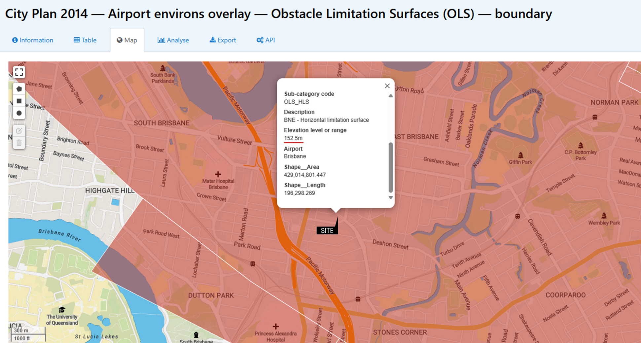
Figure 6 – Airport environs overlay – OLS (source: adapted from Brisbane City Council open data)

2.5.6 Responsive Design
PDA-WIDE CRITERIA | ASSESSMENT
Development addresses:
1. natural hazards, | Complies  As detailed in Source Document D26/6941, the proposed development appropriately addresses flood hazards affecting the site. See also E26/20009, which documents engineering support for the Flood Overlay Code Assessment.
2. appropriately responds to flooding constraints,
3. implements water sensitive urban design in stormwater and drainage systems, by:  a. maximising infiltration and opportunities for capture and reuse to minimise roof water and general stormwater run-off and peak flows,  b. using natural drainage paths and integrate with landscaping where possible,  c. ensuring sufficient capacity to safely convey runoff,  d. maintaining or improving water quality leaving the development site,  e. accounting for downstream network capacities and not worsening drainage conditions outside the development site, | Not applicable  The site is predominantly comprised of hardstand surfaces, and the proposed development will continue to feature hard stand surfaces at ground level. This is necessary due to the Heritage Place and the limited development area available behind it.
4. minimising whole of life-cycle costs of infrastructure and provides for safe and efficient maintenance. | Complies  Infrastructure adjoining the site will be comprised of streetscape elements (which will be designed in accordance with Council standards), stormwater (which will be maintained in its current form until trunk upgrades are undertaken in accordance with the DCOP), roads (which do not require upgrade), and sewer and water (which will be connected to the premises). Other than new streetscape works, there are no implications for infrastructure lifecycle or maintenance.

2.5.7 Service Infrastructure
PDA-WIDE CRITERIA | ASSESSMENT
Development:
1. ensures vehicular access, on-site servicing and parking prioritises pedestrian movements, | Complies  Vehicular access is achieved in locations which minimise pedestrian disruption.
2. maximises opportunities for co-location of servicing and parking openings within single buildings or with adjoining developments, | Complies  Servicing and parking openings are appropriately collocated.
3. does not adversely impact on the efficiency or safety of surrounding transport networks and existing major electricity and telecommunications infrastructure, | Complies  The proposed development does not impact the safety and efficiency of surrounding infrastructure.
4. provides adequate car parking for the proposed development having regard to proximity to active and public transport (Refer to Schedule 3), | Complies  As per the calculations provided later in this document, the proposed development provides an appropriate amount of car parking.
5. for non-residential uses - provides end-of-trip facilities (including bicycle parking) for cyclists and pedestrians, designed and located to promote active travel, | Not applicable  The Hotel and associated uses applied for are not expected to generate a significant demand for end of trip facilities due to the nature of the use.
6. provides water, wastewater and other services and utilities to meet the needs of the development in a timely, orderly and integrated manner, | Complies  The proposed development will be required to connect to all urban infrastructure services.
7. integrates with existing and planned infrastructure in and external to the PDA, and
8. does not adversely impact the structural integrity or ongoing operation and maintenance of sub-surface transport infrastructure. | Not applicable  The site is not located above / adjoining sub0surface infrastructure.

2.5.8 State and Major Transport Corridors, Future Transport Corridors and Infrastructure
PDA-WIDE CRITERIA | ASSESSMENT
Development does not:
1. create a safety hazard for users of a state transport corridor, a future state transport corridor, state transport infrastructure, or Council major (District classification and above) road, by increasing the likelihood or frequency of loss of life or serious injury, | Complies  The proposed development does not create safety hazards or otherwise impact infrastructure, as described.
2. compromise the integrity and function of state or major transport corridors, future state transport corridor or state transport infrastructure and associated works within a state transport corridor or Council major roads (District classification and above),
3. result in a worsening of the physical condition or operating performance of state and Council transport infrastructure and associated transport networks, including on-road public transport networks, or compromise the state’s ability to construct, maintain or operate state transport infrastructure,
4. expose the public to significant adverse impacts resulting from environmental emissions generated by state transport infrastructure, and | Complies  The proposed development does not expose the public to environmental emissions generated by State transport infrastructure.
5. compromise the structural integrity or result in a worsening of the physical condition or efficiency of roads within the PDA. | Complies  The proposed development does not compromise the structural integrity or result in a worsening of the physical condition or efficiency of roads within the PDA.

Precinct Provisions

2.6.1 Precinct 1: Woolloongabba Core
Not applicable – the site is located in Precinct 2.

2.6.2 Precinct 2: Logan Road
As shown in Figure 7, the subject site is located within Precinct 2, in a prominent location at the intersection of Logan Rd and Balaclava St, along the Creek to Cliffs Corridor. It also adjoins a road reserve intended to be repurposed as ‘new open space,’ and a ‘vehicular restriction’ area that is intended to ensure access into the space is not provided from Balaclava St.
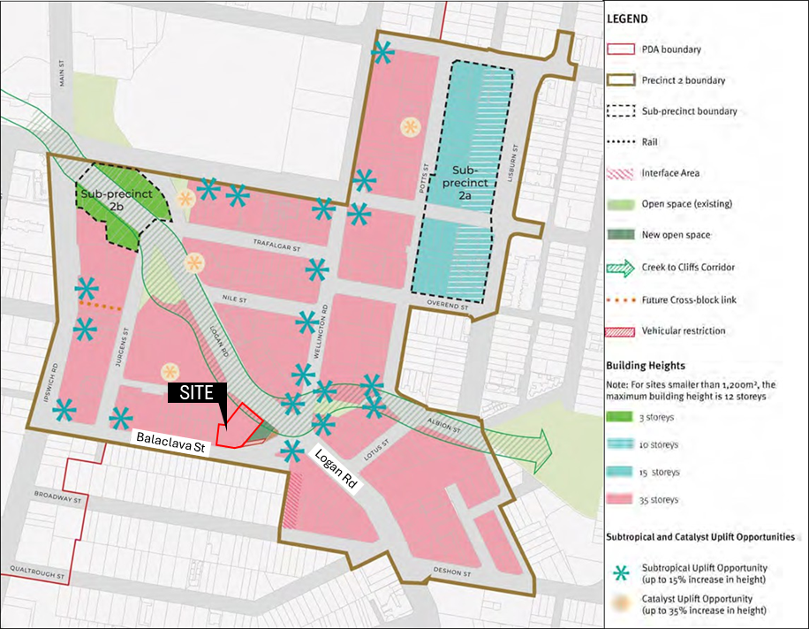
Figure 7 – Site location within the context of Map 7: Precinct 2 – Logan Rd

PRECINCT PROVISIONS | ASSESSMENT
2.6.2.1 PRECINCT INTENT
Precinct 2 will experience significant urban renewal, developing into a mixed-use neighbourhood. | Complies  The proposed development supports the intent for significant urban renewal.
Precinct 2 has a predominant focus on new homes, capitalising on the precinct’s improved urban amenity and proximity to public transport. At street-level, frontages of buildings along Logan Road, Ipswich Road, Stanley Street and Wellington Road are activated with non-residential land uses and conveniences. | Complies  The proposed development delivers 256 new homes, and provides ground floor activation to Balaclava St and Logan Rd.
The Creek to Cliffs Corridor provides opportunities for outdoor dining and other street-based activities. | Complies  The proposed development provides outdoor dining opportunities along the Creek to Cliffs Corridor, and also plans for future open space at the intersection of Balaclava St and Logan Rd, which could be used for similar / other activating purposes.
Sub-precinct 2a – Potts Street
Sub-precinct 2a provides a transition to the existing low-medium density development east of Lisburn Street. Development in this Sub-precinct comprises predominantly new homes and enhances elements of existing traditional commercial building character along the northern side of Stanley Street. An active and fine-grain frontage is provided to Stanley Street, through compatible non-residential uses. | Not applicable  The site is not located within Sub-precinct 2a.
Development in Sub-precinct 2a incorporates activated podiums capped at a maximum height of 2 storeys on Lisburn Street.
Sub-precinct 2b – Upper Logan Road Sub-precinct
2b retains a strong sense of place and character, providing dining and entertainment experiences. The scale and established character of the Sub-precinct is retained and enhanced through sensitive development that achieves consistency with existing land uses and built form | Not applicable  The site is not located within Sub-precinct 2b.
Development in Sub-precinct 2b –
1. supports the existing role and function of the area as a retail, dining and entertainment precinct, with street activation; and
2. maintains and enhances the existing commercial character and scale of the heritage buildings.
2.6.2.2 PREFERRED LAND USES
 | Complies  The proposed development:  - includes a Food and drink outlet and Multiple dwelling, which are preferred uses within Precinct 2;  - includes Hotel, Function facility, and Bar, which although not identified as preferred uses, support the precinct intent and are compatible with the preferred uses within the precinct.
  Preferred uses – Precinct 2 (excluding Sub-precinct 2a and 2b) | Preferred uses – Sub-precinct 2a | Preferred uses – Sub-precinct 2b
  - Community care centre  - Community use  - Food and drink outlet  - Health care service  - Indoor sport and recreation  - Multiple dwelling  - Residential care facility  - Retirement facility  - Rooming accommodation  - Service industry  - Shop (where no greater than 250m2 GFA for any individual tenancy)  - Showroom (up to 1,500m2 in GFA, where fronting Vulture Street/Stanley Street/Ipswich Road/Wellington Road and where integrated into a multistorey development) | - Food and drink outlet  - Multiple dwelling  - Residential care facility  - Retirement facility  - Rooming accommodation  - Shop (where no greater than 250m2 GFA for any individual tenancy) | - Bar  - Club  - Community care centre  - Community use  - Food and drink outlet  - Hotel  - Office (where not at ground level)  - Shop (where no greater than 250m2 GFA for any individual tenancy)
2.6.2.3 CONNECTIVITY, ACCESS AND PUBLIC REALM
Development in Precinct 2:
1. contributes to the delivery of the Creek to Cliffs Corridor through building form, land uses and investment in the streetscape, and | Complies  The proposed development leverages the Creek to Cliffs Corridor through the placement of active uses adjoining the corridor, streetscape upgrades, and planning for integration with future open space at the intersection of Balaclava St and Logan Rd. it also includes streetscape upgrades that support pedestrian movement.
2. improves pedestrian and cyclist movement along Logan Road, Stanley Street, Ipswich Road and Wellington Road.
2.6.2.4 BUILT FORM
Development in Precinct 2:
1. incorporates a mixed-use character, with a focus on residential uses above ground levels, | Complies  The proposed development delivers a mixed-use character (particularly within the Heritage Place), with a strong focus on residential uses above ground, within the building behind the Heritage Place.
2. activates Logan Road by delivering ground-level retail and small-scale non-residential uses, providing outdoor dining and local conveniences, | Complies  The prosed development provides outdoor dining opportunities at both street frontage.
3. maintains the fine-grain character of the ground level on Logan Road. | Complies  The Logan Rd frontage is comprised of a restored Heritage Place building, a new Food and drink outlet, and a limited area of

2.6.3 Precinct 3: Ipswich Road
Not applicable – the site is located in Precinct 2.

2.6.4 Precinct 4: Woolloongabba North
Not applicable – the site is located in Precinct 2.

2.6.5 Precinct 5: Mater Hill
Not applicable – the site is located in Precinct 2.

3 Infrastructure Plan
Development permit conditions have been prepared to address infrastructure requirements and charges, as per the provision if the Infrastructure Plan.
It is noted that the proposed development adjoins OPC-07, 0.19ha of trunk open space, intended to be delivered after 2041. Given the timing of the open space being needed, it is not considered necessary to require the provision of this space through the development application under assessment. Instead, it is noted that the proposed development has been designed to integrate with future open space provision.

Schedule 3: Car Parking Rates
Table 10: Car parking and bicycle parking rates
COLUMN 1 | COLUMN 2 | COLUMN 3
USE | PARKING RATE | ASSESSMENT
All other uses | Maximum 1 space per 300m2 GFA | The maximum allowable parking for uses other than Multiple dwelling is 1 space per 300m2 GFA. As the total non-residential GFA is 642m2, the proposed development can have up to 2 parking spaces.  The proposed development may provide the following car resident parking as per the rates identified in Column 2:  - 52x 1-bedroom dwellings – 26 parking spaces  - 179x 2-bedroom dwellings – 179 spaces  - 25x 3-bedroom dwellings – 38 spaces  - Total allowable – 243 spaces  The proposed development provides a total of 243 spaces, including both residential and non-residential parking. As such, the proposed development complies with the maximum parking rates.  In relation to visitor parking, 0.15 visitor spaces are required per dwelling. Given there are 256 dwellings applied for, 38 spaces are required. The development complies with this requirement, providing 43 spaces.
- Multiple dwelling  - Dwelling house | - Maximum 0.5 space per 1 bedroom dwelling  - Maximum 1 space per 2 bedroom dwelling  - Maximum 1.5 spaces per 3 bedroom dwelling  - Maximum 2 spaces per 4 and above bedroom dwelling  - Minimum 0.15 visitor spaces per dwelling for visitor parking  - Parking may be provided in tandem spaces where 2 spaces are provided for 1 dwelling, and  - Visitor parking:  - is not provided in tandem configurations, and  - achieves minimum of 50% allocation within communal areas.  Note: Where car share spaces are provided they will not be included in the maximum car parking calculation for the use.
- Short-term accommodation  - Rooming accommodation | Maximum 0.25 spaces per room or unit.
- Hospital  - Major sport, recreation and entertainment facility | Car parking rates to be determined by a car parking management plan submitted at the time of a development application.
All Uses  Cyclist and Pedestrian facilities | In accordance with City Plan 2014 Transport access parking and servicing code (as amended from time to time)

Note – The rates in this table represent an acceptable outcome. MEDQ will consider alternate performance based approaches for developments to achieve the PDA vision.

See details of non-compliances later in this document, as well as the discussion of ‘sufficient grounds’ contained in the assessment report.
Specifically, the development provides 52x 1-bed dwelling units, 170x 2-bed dwelling units, and 25x 3-bed dwelling units.
Referenced as an assessment benchmark by the Scheme.
The open space is identified as trunk infrastructure item OPC-07. However, design details and tenure arrangements are yet to be determined, in consultation with Brisbane City Council.
Footnote 8: For guidance, refer to Schedule 6
Footnote 9: For guidance, refer to Table 2.
Footnote 10: For guidance, refer to: a. Schedule 6 b. Brisbane City Council’s New World City Design Guide: Buildings that Breathe c. QDesign Manual d. Crime Prevention Through Environmental Design Guidelines (Queensland Government) and the Crime prevention through environmental design planning scheme policy in Brisbane City Plan 2014 e. Brisbane City Plan 2014 - Park planning and design code and Infrastructure design policy.
Typically, the first 4 levels of a building. In this case, the podium is comprised of 6 levels.
The applicant has demonstrated that service vehicle access via Balaclava St cannot be achieved because this would require ramping down towards Logan Rd which conflicts with the tower footprint, rendering the development unfeasible.
Footnote 11: For example, towers may be setback from lower levels of buildings to avoid the perception of visual bulk.
Footnote 12: Particularly in locations mapped as 'interface areas' in the precinct plans in section 2.6.
Footnote 13: Acceptable Outcomes are only one way of demonstrating that development is consistent with the relevant PDA-wide Criteria. Alternate outcomes will be considered. MEDQ will consider alternative performance based approaches for developments to achieve the PDA Vision.
While it is noted this provision pertains to acceptable outcomes and does not require ‘sufficient grounds’ per se, sufficient grounds for approving the development despite its conflict with the PDA wide criteria exist and are acknowledged in this table.
Built form, item 10.
Footnote 16: Refer to Table 2: Acceptable Outcomes, Schedule 6 – Woolloongabba PDA Public Realm and Planting Guideline, and QDesign Manual for guidance.
Footnote 17: Heritage places are identified in the Queensland Heritage Register, DAMS and the Heritage Overlay of the Brisbane City Plan 2014. For guidance, refer to the State Development Assessment Provisions (SDAP) State Code 14: Queensland Heritage, DAMS, and the Burra Charter: the Australia ICOMOS Charter for Places of Cultural Significance, 2013 and the associated Practice
Footnote 18: Cultural heritage significance has the meaning given to it under the Schedule Dictionary of the Queensland Heritage Act 1992.
Footnote 19: Pre-1911 buildings are identified on the Pre-1911 building overlay map of the Brisbane City Plan 2014.
Footnote 20: A Registered Professional Engineer Queensland (RPEQ) must undertake an assessment and reporting to demonstrate the structural stability of a building.
Footnote 21: Commercial character buildings are identified on the Commercial character building overlay of the Brisbane City Plan 2014.
Footnote 22: A Registered Professional Engineer of Queensland (RPEQ) must undertake an assessment and reporting to demonstrate the structural stability of a building.
Footnote 23: For guidance, see Brisbane City Plan 2014: a. Flood overlay code and Flood planning scheme policy b. Coastal hazards overlay code c. Infrastructure design code d. Landscape works code e. Operational work code f. Outdoor lighting code g. Potential and actual acid sulfate soils overlay code h. Stormwater code i. Transport air quality corridor overlay code j. Transport noise corridor overlay code, and k. Infrastructure design planning scheme policy.
Footnote 24: For guidance, see Brisbane City Plan 2014, Schedule 6.
NB – activities such as brewing are likely to require approval for additional land uses, such as Medium impact industry.
Footnote 25: The MEDQ may require a wind analysis report.
Footnote 26: Residents close to the Gabba Stadium can expect higher levels of noise and light spill (including from the light towers). Buildings should be designed and constructed to reduce sound pressure level between the exterior of the building and bedroom and living room, (of LLeq,T 20dB at 63Hz).
Footnote 27: For guidance, refer to Brisbane City Plan 2014 Airport environs overlay code. The MEDQ may also seek advice from the Civil Aviation Safety Authority (CASA).
Footnote 28: Archaeological artefact discoveries are required to be reported in accordance with the Queensland Heritage Act 1992.
Footnote 29: Development potential means what can reasonable be achieved under this Development Scheme or existing development approvals.
Subject to detailed assessment, larger setbacks may be achieved at the adjoining site/s. However, for current assessment purposes, it is assumed at this time that equivalent setbacks will be delivered on adjoining sites.
Footnote: 30: Refer to the Air quality (planning) criteria of the Brisbane City Plan 2014 Transport air quality corridor overlay code
Footnote 31: Refer to the Air Quality policy in Brisbane City Plan 2014.
Footnote 32: Refer to Tables 8.2.13.3.B,.C and D of the Industrial amenity overlay code in Brisbane City Plan 2014.
Footnote 33: Refer to the Air Quality planning scheme policy as per Brisbane City Plan 2014.
Footnote 34: The existing Brisbane Cricket Ground infrastructure designation under the Planning Act continues under s.47 of the ED Act.
https://data.brisbane.qld.gov.au/explore/dataset/cp14-airport-environs-overlay-obstacle-limitation-surfaces-ols-boundary/map/?location=14,-27.49255,153.03753&basemap=jawg.streets, accessed 27 Jan 2026.
Footnote 35: Refer to Brisbane City Plan 2014 Flood Overlay Map.
Footnote 36: The MEDQ may request a site-based flood risk assessment.
Footnote 37: For guidance, refer to the requirements set out in Brisbane City Plan 2014 Stormwater code.
Footnote 38: For guidance, refer to the requirements set out in Brisbane City Plan 2014 Stormwater code and the Flood Overlay Code and Flood Planning Scheme Policy.
Footnote 39: and servicing planning.
Footnote 40: The unique transport needs of the Mater Hospitals, such as high patronage of ambulances, delivery vehicles, taxis, and private vehicles, are also recognised and protected, where relevant.
Footnote 41: Urban Utilities Water NetServ Plan for existing and/or future trunk assets is to be considered during assessment.
Footnote 42: Ibid.
Footnote 43: Development located proximity to sub-surface transport infrastructure is to be supported by the submission of engineering and geological analysis. MEDQ may seek advice from relevant asset owners as required.
Footnote 44: Refer to SDAP - State Code 3: Development in a busway environment, State Code 5: Development in a State-controlled transport tunnel environment and State Code 6: Protection of state transport networks.
Footnote 45: Refer to State Development Assessment Provisions – State Code 1: Development in a state-controlled road environment State Code 2: Development in a railway environment, State Code 3: Development in a busway environment, State Code 5: Development in a State-controlled transport tunnel environment and State Code 6 – Protection of state transport networks.
Footnote 46: For guidance, refer to the State Development Assessment Provisions (SDAP) and Development Assessment Mapping System (DAMS) for the purposes of addressing State interests.
Footnote 47: For guidance, refer to Brisbane City Plan 2014 Road Hierarchy overlay map.
Footnote 50: Refer to Schedule 6
Footnote 51: Refer to Schedule 7.

