Assessment Report – Low Complexity DA

Assessment Team
DA – Planner | Vivian Lun | DA – Manager | Leila Torrens
DA – Engineer | Vikum Perera
Decision Delegate | Beatriz Gomez, Director EDQ Development Assessment

Recommendation
It is recommended;

- That the Delegate, under delegated authority and in accordance with the Economic Development Act 2012 (ED Act), approve the development application for a PDA Development Permit for Reconfiguring a Lot for 3 Lots into 3 Standard Format Lots and 3 Volumetric Format Lots over 2 Stages at 520 Beams Road and 29 and 35 Plaza Place, Carseldine, subject to the Approved Plans and Documents and the PDA Development Conditions (refer Decision Notice at D25/193094).

- That the PDA Decision Notice be provided to the applicant and the relevant local government, in accordance with section 89 of the ED Act.

Application Details

DA Reference No: | DEV-2025-FTZ-3977
Type of Approval: | PDA Development Permit for Reconfiguring a Lot
Proposal Description: | 3 Lots into 3 Standard Format Lots and 3 Volumetric Format Lots over 2 Stages
Applicant: | De Luca Corporation Pty Ltd C/- Bennett and Bennett Group
Properly Made date: | 24 November 2025
Info Request date: | -
Decision Due date: | 27 January 2026

Property & Site Details
Priority Development Area: | Fitzgibbon
Site Address: | 520 Beams Road and 29 and 35 Plaza Place, Carseldine
Real Property Description: | Lots 5001, 5003 and 9001 on SP339577
Area of Site: | Lot 5001: 12,220m²  Lot 5003: 1,409m²  Lot 9001: 1,179m²
Property Owner(s): | Lots 5001 & 9001 on SP339577 - Carseldine Village Pty Ltd  Lot 5003 on SP339577 - Buddysrn Pty Ltd
Locational context: | The subject site is located at 520 Beams Road, Carseldine and is part of the broader Carseldine Urban Village in Precinct 1, a residential development being delivered by EDQ Urban Development Team.  The site is part of an existing urban area, surrounded by low density residential development, including the terrace home development of Carseldine Village to the east. On the northern side of Beams Road there is an existing commercial centre, known as the Clock Tower.  The site is bounded to the west by the Government Office Precinct, which is a Transport and Main Roads office building. To the south is an extensive bushland area, leading to Cabbage Tree Creek.
Site attributes: | The site contained a significant amount of vegetation that has been cleared as the residential development has progressed. The clearing of the vegetation has been off-set by compensatory planting elsewhere, the establishment of fauna nesting boxes and fauna spotters during the construction process to ensure the impacts of development are mitigated as much as possible.

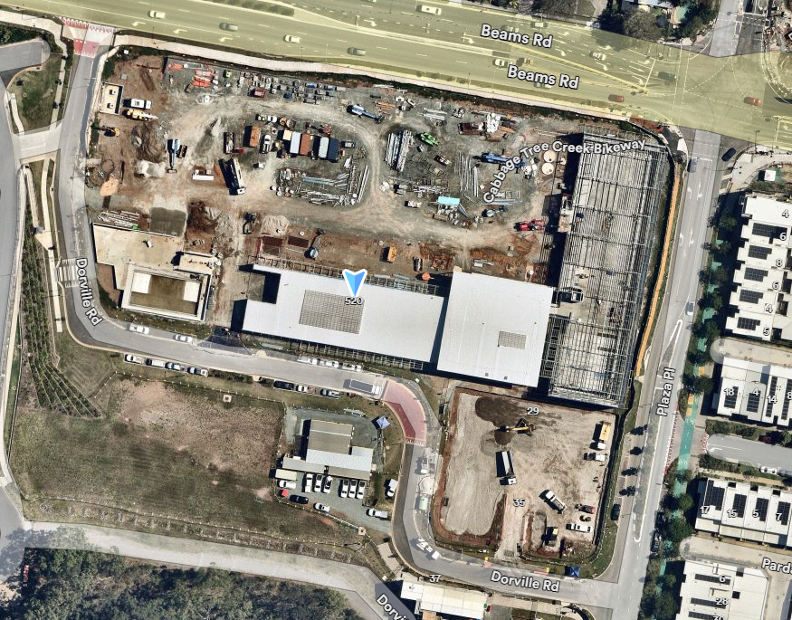
Figure 1 – Aerial Mapping of The Site

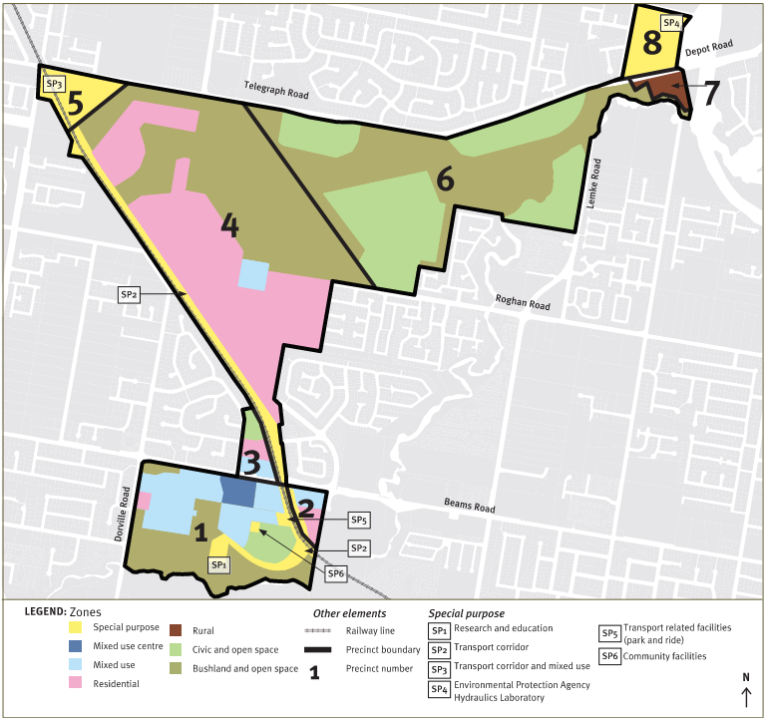
Subject Site
Figure 2 – Precinct Plan – Site Location within the PDA

State Interests

A detailed state interest checklist has been completed and saved in Source D25/192046. The application seeks approval for the subdivision on 3 lots that has approval for future buildings with mixed uses including multiple dwelling and other land uses. No additional building structure or physical works are proposed beyond subdividing the lots itself. As such, the proposal does not trigger any relevant state interests under the applicable planning framework.

Relevant Site History & Preliminary Approval

Application Type | Date | Description
Development Approval for Reconfiguration a Lot for 1 into 5 lots, new road, access easement and balance lot (DEV2022/1321) | Approval date 27 February 2023 | Carseldine Village development, subdivide lots for future development
Change to Development Approval for Reconfiguration a Lot for Over 2 Stages (DEV2022/1321/9) | Approval date 9 August 2024 | - Stage V1: 3 Mixed Use Lots, 1 Open Space Lot (Public Plaza), 1 Open Space Lot (Drainage), New Road, and Boundary Realignment;  - Stage V2: Access Easement.
Development Approval for Material Change of Use for Retail Uses (Shops, Food Premises); Commercial Uses (Medical Centre, Office), Sport, Recreation and Entertainment Uses (Indoor Sport and Recreation); Residential Use (Multiple Residential) and Service, Community and Other Uses (Community Facility)  (DEV2023/1468) | Approval date 19 September 2024 | The construction of the “Village Heart” of the Carseldine Village development, which is described as a residential community delivered by Economic Development Queensland (EDQ) at the subject site. At the time of the approval, the Village Heart was comprised of 6 lots, with 4 of the lots being subject to this application and the first three stages of development of the ultimate Village Heart.
Change to Development Approval for Material Change of Use (DEV2023/1468/8) | Approval date 5 June 2025 | Change to conditions 33, 65 and 87 (same condition but in different stages).

Assessment & Key Issues

The proposal seeks to subdivide existing Lots 5001, 5003 and 9001 on SP339577 for land management
purposes. The application will realign the boundaries of the lots into the ultimate configuration and excise the future commercial uses and basement area approved under (DEV/2023/1468/8).

The development proposed a staged subdivision detailed as follows:
- Stage 1: Reconfiguring a lot: three standard format lots into three standard format lots and one volumetric lot.
- Stage 2: Reconfiguring a lot: one standard format lot into two volumetric format lots and one standard format (remainder) lot.

Stage 1
- Step 1
- Lot 5010: Standard format lot for the Carseldine Village commercial buildings.
- Lot 5030: Standard format lot for the mixed-use building.
- Lot 9010: Standard format lot required for titling of underlying basements in further actioned in step 2.

- Step 2
- Lot 91: Standard format remainder lot for the future plaza.
- Lot 100: Volumetric format lot to facilitate a portion of the future mixed-use building’s basement.

Stage 2
- Lot 98: Volumetric format lot for the ground floor retail/food and beverage tenancies and bin area.
- Lot 99: Volumetric format lot for the ground floor commercial/retail tenancies and designated carparks.
- Lot 503: Standard format remainder lot.

An assessment of the proposal against the Fitzgibbon PDA Development Scheme has been undertaken. The proposal generally complies with the key elements of the Development Scheme, as summarised below.

PDA-Wide Criteria | Applicant Response | Assessment
3.12 Lot Design
Lot sizes and dimensions must enable buildings to be sited to:  - protect natural and cultural features, including significant vegetation  - address site constraints including slope, soil erosion, flooding and drainage  - retain special features such as trees ensure that lots are not subject to  - unreasonable risk, hazard, noise impacts or air quality impacts  - ensure reasonable buffers between existing or potential incompatible land uses  - maximises solar orientation benefits to assist energy rating targets.  Neighbourhood and lot design for mixed residential development up to 3 storeys in height and with a net residential density up to 30 dwellings per hectare, will comply with ULDA guidelines and best practice Standards.  Other lots must have an appropriate area and dimension for siting and construction of the buildings, the provision of outdoor space, the relationship to adjoining development and public realm, safe and convenient vehicle access, servicing and parking.  Lot frontages must address streets and civic and open space. This is to facilitate personal and property security, surveillance of footpaths and public open space to deter crime and vandalism. | The proposal is to facilitate the ultimate land tenure arrangements for the overall development in line with the approved material change of use approval.  Accordingly, as the proposal is consistent with the existing approval it is consistent with the intent of the development scheme | The proposed development seeks to realign the lot boundaries for the ultimate plaza lot the integration with the ground floor commercial will be maintained, with no reduction in plaza space. Boundary realignments are exempt development under the Fitzgibbon Development Scheme.  There is no material change to the premises proposed as part of this application.  The proposed lots are well located and will be able to be connected to all urban services.

Internal Referrals

6.1 Engineering
Comments and conditions regarding the proposal were received from engineering on 28 November 2025 (Source Ref: D25/173974)

6.2 Infrastructure Charges
Model conditions regarding infrastructure charges for the proposed development are recommended to be included in any approval (Source Ref: E25/290343).

External Referrals

Given the nature and scale, the application was not referred to any external parties for comment and advice.

PDA Development Conditions

Model conditions are recommended to be included in the approval for the proposed development. Given some of the site-specific and unique requirements of the proposal, the following non-standard conditions are also recommended.

Non-standard condition | Timing | Reason for inclusion
The Construction of Buildings  - Submit evidence to EDQ demonstrating that Conditions 50 to 68 of Development Permit DEV2023/1468 have been complied with. | Prior to survey plan endorsement for Stage 2. | To ensure the volumetric lots will be tied to the future building.

On 17 December 2025, the draft conditions were provided to the applicant for comment (Source Ref.: E25/290391).

On 19 December 2025, Applicant responded comments are as below:

Conditions | Applicant Comments | EDQ Comments
2. The Construction of Buildings  Submit evidence to EDQ demonstrating that Conditions 50 to 68 of Development Permit DEV2023/1468 have been complied with. | We understand that EDQ just wants security that the volumetric lots will be tied to the future building. We don’t think that the conditions as proposed is suitable. As it currently is written this would require that the residential tower would need to be 100% completed prior to the sealing of the volumetric lots as part of Stage 2. Potentially delaying when the stage 2 subdivision can be established. To give EDQ security we proposed the conditioned to be similar to the following:  “The survey plan associated with Stage 2 cannot be submitted for endorsement until the building works for the ground floor associated with DEV/2023/1468/8 has been completed to framing.” | As the subdivision includes volumetric lots, it would be cleaner to link the lots to the future building. After considering the applicants representations, the condition has been reworded to state:  Submit evidence to EDQ by a suitably qualified person demonstrating that all service connections have been appropriately constructed in accordance with relevant standards.  Timing: Prior to plan sealing of Stage 2.  This has been accepted by the applicant. Source ref E26/15774
3. Easements  - Submit documentation to demonstrate that all original easements applicable to the site have been reinstated as part of the creation of the new allotments. | We also note that condition 3c is unnecessary and should be deleted. It is slightly confusing and overall new and existing easements will be shown on the survey plan. We recommend the condition be deleted. | After reviewing the original and amended approvals, there are no easements proposed, and state mapping does not show any easements within the subdivision area. This condition can be removed.

After few discussions internally and with the applicant, the applicant has agreed with the proposed change to condition on 22 January 2026 (Source Ref.: E26/15609).

2. | Service Provision  Submit evidence to EDQ, certified by a suitably qualified person, demonstrating that all service connections have been appropriately constructed in accordance with the relevant standards. | Prior to survey plan endorsement of Stage 2

Human Right Impact Assessment

In accordance with the (HR Act), the human rights relevant to this decision are:
- Freedom of movement;
- Freedom of expression;
- Property rights (right to own property and not be arbitrarily deprived of property).

It is considered that a decision to approve the proposed development will not limit (or interfere with) the above listed human rights as;
- the development will not arbitrarily restrict the movement of people or limit the ability of people to move through open space;
- public notification of the application was not required;
- the development will not adversely affect how people may use their land.

Appendix 1 – Proposal plans
