Assessment Report – Low Complexity DA

Assessment Team
DA – Planner | Essen Joseph | DA – Manager | Essen Joseph
DA – Engineer | N/A
Decision Delegate | Beatriz Gomez, Director, Development Services

Recommendation
It is recommended that:

- The Delegate accepts the change proposed as part of the amendment application will not result in a substantially different development.

- The applicant be advised of the Delegate’s decision to accept the change as not substantially different development, in accordance with 99 of the Economic Development Act 2012 (ED Act).

- The Delegate, under delegated authority and in accordance with the ED Act, approve the application to amend PDA Development Permit DEV2024/1577 for Reconfiguring a Lot (2 Lots into 2 Lots) at 15-19 Cairns Street, East Brisbane, subject to the Approved Plans and Documents and the PDA Development Conditions (refer Decision Notice – Source Ref D26/596).

- That the PDA Decision Notice be provided to the applicant and the relevant local government, in accordance with section 89 of the ED Act.

Application Details

DA Reference No: | DEV-2025-WGB-4025  (previously DEV2024/1577)
Type of Approval: | Development Permit for Reconfiguring a Lot (2 Lots into 2 Lots)
Proposal Description: | Amendment to Condition 2 to enable a different form of easement to be created than that approved
Applicant: | Dean Bradley, Shaun Price and Rachel Drew
Properly Made date: | 18 Dec 2025 (Source Ref E25/288307)
Info Request date: | N/A
Decision Due date: | 6 Feb 2026 (30 BD KPI)

Property & Site Details
Priority Development Area: | Woolloongabba PDA
Site Address: | 15-19 Cairns Street, East Brisbane
Real Property Description: | Lots 0, 1, and 3 on GTP2652
Area of Site: | 624 m²
Locational context: | Precinct 4 - Woolloongabba North
Site attributes: | Generally flat, improved with two Dwelling houses, contains landscaping at rear.

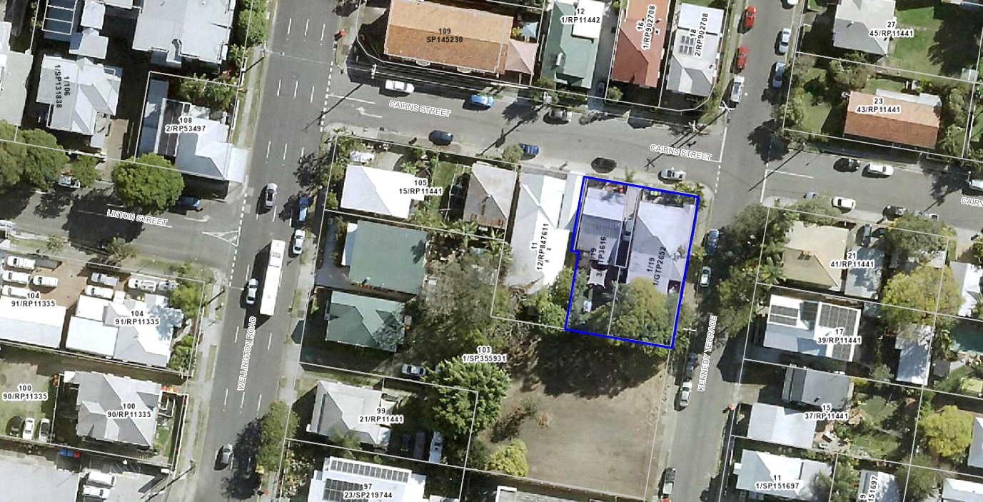
Figure 1 – Site location plan (source: Brisbane City Plan mapping online, accessed 11 Dec 2025)

State Interests
There are no matters of State interest to be considered in the assessment of this application.

Relevant Site History & Preliminary Approval
On 25 February 2025, the MEDQ granted a Development Permit for Reconfiguring a Lot to enable the common property (Lot 0), located between Lots 1 and 3 to be amalgamated into Lot 3, with an easement placed over it to provide access to Lot 1.

Assessment & Key Issues

Not substantially different development
As per s99(2) of the ED Act, amendment application may be made only if MEDQ is satisfied the change would not result in the relevant development being substantially different.

Schedule 1 of the DA Rules under the Planning Act 2016 provides an appropriate benchmark for testing whether the proposed change would result in ‘substantially different’ in comparison to the approved development.

In this case, the following assessment against the DA Roles, Schedule 1, demonstrates that the amendment application will not result in substantially different development.

DA Rules, Schedule 1 (Guidance Criteria) | Assessment
involves a new use | No
results in the application applying to a new parcel of land | No
dramatically changes the built form in terms of scale, bulk and appearance | No
changes the ability of the proposal to operate as intended | No
removes a component that is integral to the operation of the development | No
significantly impacts on traffic flow and the transport network, such as increasing traffic to the site | No
introduces new impacts or increases the severity of known impacts | No
removes an incentive or offset component that would have balanced a negative impact of the development | No
impacts on infrastructure provisions | No

Assessment, generally
The applicant has submitted that the purpose of the easement was intended to be for ‘access to services’ located underground, not to provide ‘access’ (i.e. vehicular access) to Lot 1. This was not clear in the original application material, and a condition of approval was imposed for the creation of an access easement.

While no issues were raised at the time of the original decision, the issue became apparent when the applicant sought EDQ endorsement for a survey plan (under application number DEV2024/1577/2).

There are no issues with the creation of an easement for access to services, as proposed, and there is no requirement to provide a space for vehicular parking or access.

The proposal is supported and recommended for approval.

Internal Referrals
No internal referrals were required, given the minor nature of the proposed change.

External Referrals
No internal referrals were required, given the minor nature of the proposed change.

PDA Development Conditions
It is recommended that Condition 2 be amended from:

Condition | Timing
Access easement  An access easement burdening Lot 3 in favour of Lot 1 as shown on the approved plans is to be created at the registration of the survey plan. | As indicated

To:

Condition | Timing
Easement  An easement for access to services, burdening Lot 3 in favour of Lot 1, as shown on the approved plans, is to be created at the registration of the survey plan.  Note – Services means stormwater drainage, water and sewerage supply services. | As indicated

Human Right Impact Assessment

In accordance with the Human Rights Act 2019 (HR Act), the human rights relevant to this decision are:

- Freedom of movement;
- Freedom of expression;
- Property rights (right to own property and not be arbitrarily deprived of property).

It is considered that a decision to approve the proposed development will not limit (or interfere with) the above listed human rights as:

- the development will not arbitrarily restrict the movement of people or limit the ability of people to move through open space;
- public notification of the application was not required;
- the development will not adversely affect how people may use their land.

No specific guidance is provided under the ED Act.

